Stories from
The Dhammapada
With Dharma Discussions for Kids

Adapted for kids and illustrated by
Margaret Lisa Buschmann

Published in 2023 by:

International Buddhist Society of Pennsylvania
Pennsylvania Meditation Center
1999 South Valley Rd.
Crystal Spring, Pennsylvania 15536 USA
https://www.PAmeditation.info

ISBN 978-1-7341433-9-3

Photo of lotus by Eric Wang on Unsplash.

May you be well, happy and peaceful!

May all beings be well, happy and peaceful!

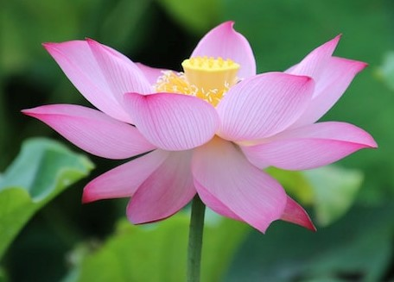

INTRODUCTION AND ACKNOWLEDGMENTS

The format of this book, with a Dharma discussion on a theme from each story, is designed to introduce children to ethics (character development) and basic Buddhist concepts, and to gently guide them in identifying and applying those ethics and concepts in everyday modern life with all its challenges.

The goal is to assist children in developing their good character, virtues, confidence, resilience, awareness and good habits so they have a firm foundation for a successful, happy and peaceful life.

The Dharma discussion is a suggested outline for discussion, to be modified to suit the students’ ages and backgrounds. It should invite students to pose their own questions, concerns and hypotheticals, and to share ideas, examples and solutions from their own experiences. The question and answer (with answers shown in parentheses) are to aid comprehension and recollection of the story. It is suggested that teachers and parents recite a prayer along with the children before starting with the story, and conclude the dharma discussion with a dedication of merit.

I am very grateful to Khenpo Sumdup Rinpoche and Bhante Huruluwewe Chandrawansa Thero and for their guidance, inspiration and support for teaching children at their temples in the past several years. I thank all my students over the past years for their questions, comments and responses to the stories and discussions which have helped immeasurably in editing this book. I thank my co-teachers, Aleks Smirnov and Fawn Bui, for all their thoughtful suggestions for revisions.

M. Lisa Buschmann
Children’s Dharma Program Instructor
International Buddhist Society of Pennsylvania
Drikung Dharma Surya Center
DharmaKids.org

CONTENTS

List of Sources

Story: Theme:

1. Treasurer Catfoot Makes a Tiny Donation………..Merit and Generosity

2. Little One-Robe………………………………………………..When to Make Merit

3. Holy Man Makes a Horrible Scene……………………Misbehavior of Others

4. Four Hungry Little Monks ………………………………..When Others are Hostile

5. Bored With the Dharma…………………………………..Habits and the Three Poisons

6. The Weaver’s Daughter……………………………………Lovingkindness and Wisdom

7. Bribed to Hear the Dharma……………………………..Happiness and Faith

8. Little By Little ………………………………………………….Awareness and Service

9. The Acrobats……………………………………………………Attachment and Impermanence

10. The Boy and the Spirits……………………………………Fear and Mindfulness

11. Hot Oil Attack………………………………………………….Ill Will and Lovingkindness

12. The Skulls………………………………………………………..Power

LIST OF SOURCES

1. Eugene Watson Burlingame, A Treasury of Buddhist Stories from the Dhammapada Commentary, rev. Bhikkhu Khantipalo, Buddhist Publication Society, Kandy 1996.

2. K. Sri Dhammananda, Ven. Dr., Dhammapada, Sasana Abhiwurdhi Wardhana Society, Kuala Lumpur, 1992.

3. Weragoda Sarada Maha Thero, Ven., Treasury of Truth, Illustrated Dhammapada, The Corporate Body of the Buddha Educational Foundation, Taiwan 1993.

4. Ñanamoli, Bhikkhu, The Life of the Buddha, Buddhist Publication Society, Kandy 1992.

Chapter 1 Pictures
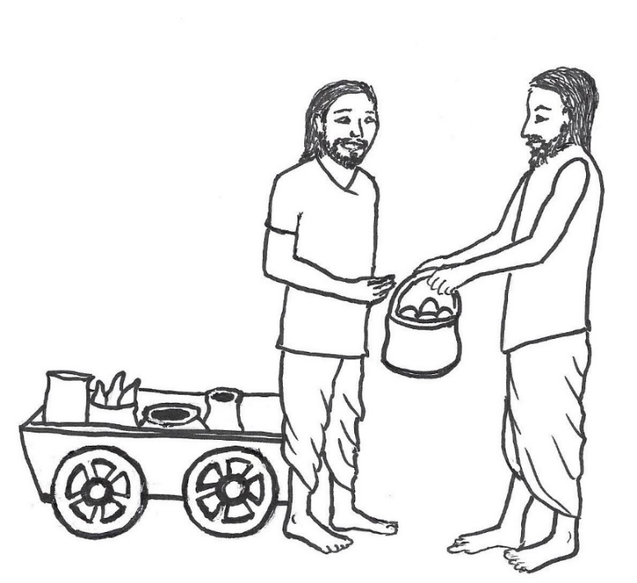

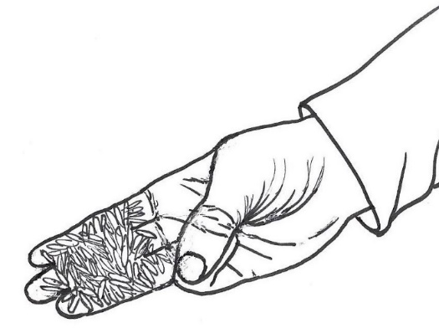

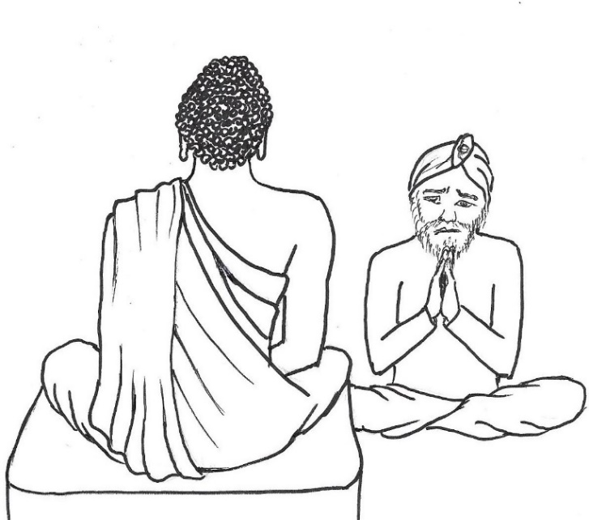

CHAPTER 1 – TREASURER CATFOOT MAKES A TINY DONATION

One day in the town of Savatthi in India around 2,600 years ago, a big group of people made an offering of lunch to the Buddha and his monks. Later, thinking about the good deeds of the people offering the meal, the Buddha gave a Dharma talk in which he said,

“When a man is generous, giving to others, but does not encourage others to be generous, in his future lives he will be wealthy but not popular. When a man is not generous himself but he encourages others to be generous, in his future lives he will be popular but not wealthy. When a man is neither generous nor encourages others to be generous, in his future lives he will be neither wealthy nor popular. When a man is generous and he also encourages others to be generous, he receives the merit to be both wealthy and popular in future lives.”

Listening to the Buddha, the people were inspired to follow his teaching. One of the men thought to himself, “This is indeed a wonderful thing! Right away I am going to practice what he is teaching and make merit leading to wealth and popularity.”

As the Buddha was getting up to leave, the man went up to him and invited him to come to his house for lunch the next day, saying, “Lord, accept our offering of food tomorrow.”

The Buddha asked him, “How many monks do you need?”

“All the monks you have, Lord,” was the man’s reply. Feeling very generous, he wanted to serve as many monks as possible.

The Buddha accepted his invitation and agreed to come to his house for lunch.

The man went through the town, walking up to each house, and announced, “Ladies and gentlemen, I have invited the Buddha and his monks for tomorrow’s meal. Please donate rice and whatever else is needed for making rice-porridge and other kinds of food. Contribute what you wish, and provide for as many monks as you wish. Let’s do all the cooking in one place and make our offerings together.”

Many people happily donated bags of rice, bowls of vegetables, baskets of fruits, and pots of milk, butter and spices.

A rich man who was a treasurer, in charge of the town’s money, was watching the man going from house to house receiving containers of food, and wondered what he was doing. The man eventually came to the treasurer’s door, and when the treasurer opened the door, the man announced the meal planned for the monks and invited him to make donations of food.

The treasurer felt angry, thinking the man was taking other people’s offerings so he could act proudly as if he made all the offerings to the monks himself. So, the treasurer strongly disliked the man and disapproved of what he was doing.
The treasurer responded, “Bring the bowl you have.”

As the man went to bring a bowl, the treasurer murmured to himself in an irritated tone,

“This wretched man! Why didn’t he just invite as many monks as he himself can provide for? Instead, he is going around urging the entire town to give offerings!”

The treasurer then brought some grains of rice from his house, held them on three of his fingers and offered them into the man’s bowl. He also brought some beans and placed them on three of his fingers and put them in the bowl.

Because of the way he made the offering—using only three fingers, making his hand small like a cat’s paw—he later was referred to as Treasurer Catfoot.

He brought some melted butter from a little pot and dribbled just a little, drop by drop, into the bowl. He brought some sweet syrup and dribbled just a little bit, drop by drop, into the bowl.

The man placed the treasurer’s offerings apart from the offerings from other people. The treasurer saw him do this, and wondered, “Why does he place the offerings I gave him apart from the other offerings? Will he try to embarrass me by pointing out that such a rich man as me donated so little?”

So, he sent a servant boy to find out, saying, “Follow that man and tell me what he does with my offerings.”

The man took the grains of the treasurer’s rice and bits of the treasurer’s beans, butter and sweet syrup, and sprinkled all of them into the pots and bowls of rice and other foods that had been donated. As he did so, he said,

“May the treasurer receive a great reward.”

By putting bits of the treasurer’s offerings into all the pots and bowls of food, the treasurer’s donations were a part of all the foods, which made his offerings seem greater.
The servant boy went back to the treasurer and reported what he had seen.

The treasurer, still suspicious that the man was up to no good, thought, “If that man humiliates me in the middle of all those people, I will kill him the moment he mentions my name!”

The next day, the treasurer hid a knife under his clothes and went to the place where the food was going to be offered to the Buddha and his monks.

The man who had gathered all the offerings led the Buddha and monks in to where the people were waiting to serve the food, and then said,
“Lord, this food is an offering from everyone. Whether a person has given much or a little doesn’t matter. Each of us has given with faith and generosity. May all of us receive great merit.”

When he heard those words, the treasurer was shocked. He thought,

“I came here with the intention of killing this man in case he would humiliate me. But instead, he included everyone in his request for a blessing of merit, both those who donated big pots of food and those who offered only a few pinches of food. If I don’t admit my mistake and ask the man for forgiveness, then I will suffer the results of my negative karma.”

The treasurer said to the man, “My friend, I have done you a great wrong by thinking badly about you. Please forgive me.”

The man asked, “What do you mean?”

The treasurer told him the whole story, admitting, “I thought you put aside my offerings in order to embarrass me in front of everyone, and I wanted to kill you if you did so.”

The Buddha, hearing what the treasurer said and knowing everything that had occurred, said,

“One should never think of a good deed as not important, however small it may be.
Small good deeds will become big if you do them again and again, as a habit.
Wise people who do good deeds will become filled with merit, like a jar that gets filled with water drop by drop.”

Questions:

1. When a person is generous and also encourages others to be generous, what result does he receive in future lives? (wealth and popularity)

2. Why did the man invite all the monks rather than just some of the monks? (he felt generous and wanted others to join him in making offerings)

3. How did the treasurer feel when the man invited him to make a donation of food? (angry; he didn’t like what the man was doing)

4. What did the treasurer think the man was going to pretend with all the people’s offerings? (that he himself made all the offerings)

5. What did the treasurer think the man might say to humiliate him? (that he was a rich man who made such a small offering)

6. What did the Buddha teach that we should make a habit of doing, to make a lot of merit? (good deeds)

What the Buddha said:

“Māvamaññētha puññassa, na maṁ taṁ āgamissati, udabindu nipātēna, udakumbhō pi pūrati, pūrati dhīrō puññassa, thōkathōkam pi āchinaṁ.”
“Do not think lightly of merit, that ‘good results will not come to me,’ for by the falling of water drops a water jar is filled. Even doing acts of virtue little by little, the wise man fills himself with merit.”
- Dhammapada 122 (9:7)

Dharma discussion – Merit and Generosity:

What does the word “merit” mean?
The good result that comes from doing a good deed, a virtuous action, or a good karma.
What are “good deeds,” “virtuous actions” and “good karmas”?
They are acts of kindness, being generous, and helping someone. Good karma also includes spiritual practices like learning the Dharma, chanting, prayer, or meditation.
They all mean doing something that’s not for your own enjoyment, but is for the good of someone else or others, or for the good of all beings, including yourself.
There are so many good deeds we can do. Can you think of some examples?
Helping your parents at home, helping your teacher arrange the classroom, being kind to a new student so they feel welcome, offering to help carry something, rescuing a living being such as an earthworm, helping someone with homework, doing something good for the environment, offering food to someone else rather than just eating it yourself.
Those actions, and all of our good karmas, are the causes of merit, good results.
What do we mean by “good result”? It’s something like good luck, giving us happiness and positive things in our lives such as good health, a nice home, helpful people around us, kind friends, being safe and protected, having what we need, and finding a job that we enjoy doing.

What did the Buddha say about good deeds, even small good deeds? They are important;
even the little kind things we do will give good results if we do them again and again.
Like small drops of water add up to fill a jar, little good deeds add up to a lot of merit.
Imagine a jar under a dripping faucet—the drops of water seem so tiny that they would never fill the jar, but if we leave it under the faucet for a while, the jar becomes full of water.
Doing good deeds at home, at school and wherever we are—and even when our friends, sisters and brothers are not doing them—develops into a habit of being kind and helpful, which automatically creates a lot of merit.

Do you think the man in the story who collected food offerings knew that even small offerings were important?
Yes. He took the treasurer’s small offerings and treated them very specially, putting bits of them in every bowl and pot of food.
Instead of being critical, he was kind and compassionate, wanting the treasurer to receive great merit for his offerings, hoping the offerings would help the treasurer.

Why did he ask other people in the town to give food?
He wanted to practice what the Buddha had taught about encouraging others to give.
Why is it Important to encourage others to be generous, to invite others to join us in doing kind deeds?
The Buddha said that if you encourage others to give, then you will be popular in the future.
There are other reasons to encourage others to be generous, to join us in doing good deeds. Can you think of any? So they can make merit too, and have a happy life.
And to show that we care about them, so we’re not just thinking about ourselves.

When the treasurer was making his offerings, do you think he was thinking about merit? Probably not. Although he knew about karma, he was focused on his negative, critical thoughts about the man who came to his door.
Why would the treasurer have such negative thoughts about the man?
Some people don’t like seeing another person doing good deeds. They don’t like to think that he is better than they are; they always want to be the best.
So, they believe that such a person actually is selfish but is pretending to be good to get attention or some other reward.
People who are selfish tend to see others as being selfish and don’t believe that others can be unselfish.

Another reason he probably wasn’t thinking about merit is that he was more concerned about having to give something away. Although he was rich and had plenty of food, how did he feel about giving some away? He didn’t like it. He was stingy, the opposite of generous.
Stingy people think they would be happier keeping everything for themselves than being generous.

Then, after the treasurer made his little donation, he had more negative thoughts.
What were they? The fear and anger that the man would humiliate him.
And cruel thoughts—he packed a knife and was ready to kill the man.
People who are cruel often assume that others are cruel too.
So, he assumed that the man would be cruel and embarrass him.

What did the treasurer learn about the man? That he wasn’t cruel and wasn’t selfish, but was indeed kind, and appreciated his small donation, and generously wanted to share merit with everyone.

The man’s small act of kindness—inviting the treasurer to donate some food—led to the treasurer giving a small donation, which led to his good fortune of meeting the Buddha and hearing the Dharma, which changed his life for the better.

Even such small acts of kindness can have such wonderful life-changing results!
Chapter 2 Pictures

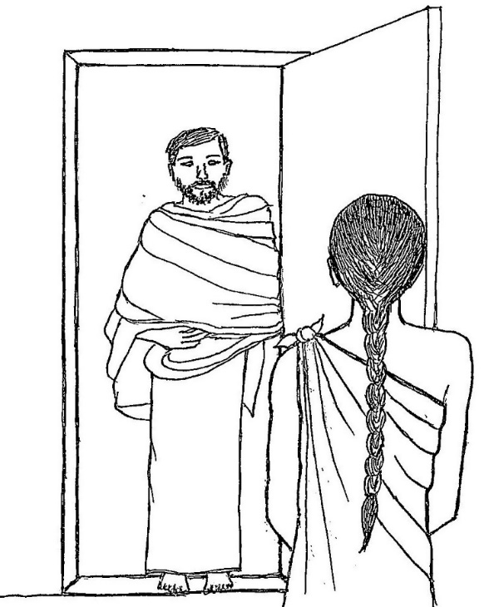

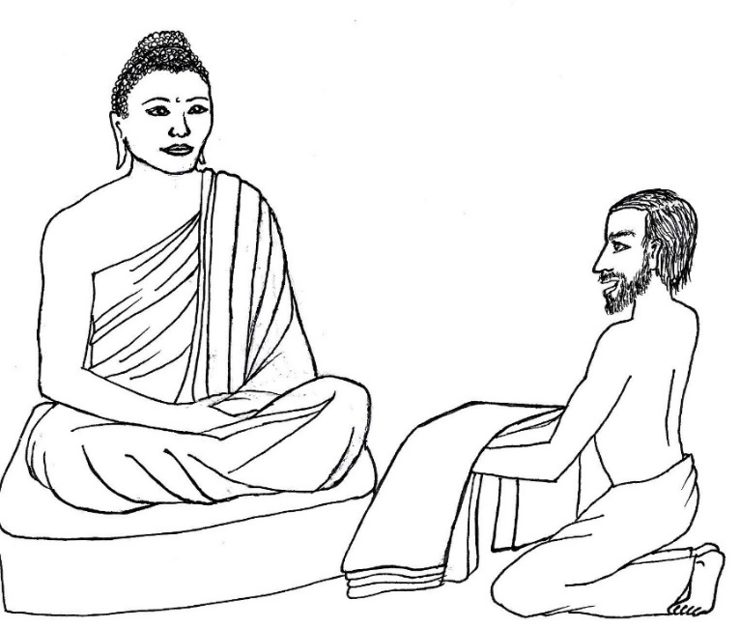

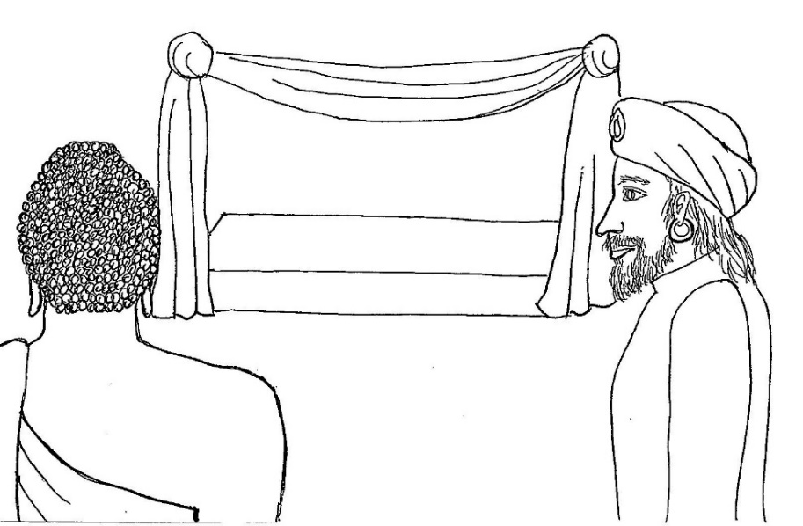

CHAPTER 2 – LITTLE ONE-ROBE

A very poor man called Little One-Robe lived with his wife in the town of Savatthi. He was called Little One-Robe because he was a short, slender man who owned only one thick cloth to wear over his upper body. He was so poor that he had only one thin cloth to wear over his lower body, and his wife had only one cloth to cover her body. They had no money to buy any other clothing. When either the husband or wife wanted to go outside, they had only the one thick cloth to cover their arms and shoulders like a jacket to protect them from the blazing sun or the cool wind. So, only one of them could go out at a time and the other stayed inside at home.

One day, a messenger went around the town announcing that the Buddha would be giving a Dharma talk at the monastery the next day. Hearing the announcement, Little One-Robe said to his wife,

“Dear, an announcement was made that there will be a Dharma talk at the monastery in the afternoon and evening tomorrow. Do you want to go and hear the Dharma in the daytime or in the evening? We don’t have enough outer clothing between us to go together.”

The wife replied, “Okay dear, I’ll go in the daytime.”

The next day, she put on the thick cloth and went to the monastery. Little One-Robe waited at home and when his wife returned in the evening, she gave him the thick cloth to wear. As he stood in the doorway to say goodbye to her, he noticed how joyful she looked. How could she be so happy when they were so poor? He walked to the monastery wondering what made her so happy.

When he arrived, he seated himself right in front of the Buddha and listened to the Dharma. As he listened, he felt extreme joy arising in him. He felt so full of joy that he wanted to do something to show his deep appreciation to the Buddha. He wanted to offer him a gift in gratitude for the wonderful teaching. But what should he give? The most precious thing that he owned was the thick cloth he was wearing.

“That’s it,” he thought, “I’ll offer him this thick cloth.”

But the next moment, he thought, “If I give this cloth to the Buddha, there will be no warm clothes left for my wife or me.”

“But I want to make an offering,” he thought.

Then he argued within his mind, “If I give this one cloth away, how will I be able to buy another cloth? I don’t have enough money. What if it’s cold outside, and I have nothing to keep me warm? What if I become ill? What if I have to spend the whole day outside in the sun with nothing to protect me? Maybe the Buddha doesn’t need this cloth. Maybe it will just be given away to someone else. Also, what will my wife think if I give it away? Maybe she will be upset.”

So many thoughts discouraged him from giving away his thick cloth.

But a feeling of generosity arose in his heart, and he thought, “I will offer this cloth! It’s what I want to do!”

And then the doubts arose again, as he thought, “Am I crazy? I can’t offer the one piece of warm clothing I have. I’m not wealthy like all these people who come here with many offerings. There are so many people giving gifts, mine will be so unimportant compared to all the lavish offerings from everyone else.”

His mind was at war with itself, thinking, “I will give it!” and then, “No, I will not give it!”

Hours passed as the Buddha continued teaching. Finally, the evening program was about to end and Little One-Robe still had not made up his mind. He thought,

“While I have been fighting with thoughts of generosity and thoughts of myself, hours have passed. If these powerful thoughts of myself increase, they will not let me escape suffering and I will have future lives of suffering. I will therefore give my gift.”

So, Little One-Robe finally overcame a thousand doubting thoughts and followed his thought of generosity. Taking the thick cloth, he laid it at the Buddha’s feet and called out with a loud voice,

“I have conquered! I have conquered! I have conquered!”

King Pasenadi, the king of Kosala, happened to be there, listening to the Dharma. When he heard Little One-Robe’s loud voice, he was very curious, and said to his assistants,

“Ask him what he has conquered.”

The king’s men went to Little One-Robe and asked him, “What or who is it that you have conquered?”

Little One-Robe explained his situation, his difficult decision to offer the cloth, and the conflicting thoughts that arose in his mind before he conquered his selfish thoughts and decided to give the gift.

When the men reported the explanation to the king, he said, “It was a hard thing to do what that man did. I will do him a kindness.”

So, the king ordered a new set of clothes—a cloth for the upper body and a cloth for the lower body—to be given to Little One-Robe.

When presented with the new set of clothes from the king, Little One-Robe gave them immediately to the Buddha, thinking, “Ah! Now I have something new and beautiful to offer to the Buddha to show my gratitude for his wonderful teaching!”

Then the king, thinking that Little One-Robe must keep something for himself, doubled his gift, giving Little One-Robe two pairs of cloth.

Little One-Robe was thrilled to offer these also to the Buddha.

The king had thought that he would at least keep one set of clothes even if he offered the other to the Buddha. So, he doubled his gift again, and gave Little One-Robe four sets of cloth.

When he again offered all of them to the Buddha, the king doubled his gift again, giving eight sets. When the same thing happened, he gave sixteen sets. Again, Little One-Robe offered all of them to the Buddha.

Finally, the king gave 32 sets of cloths to Little One-Robe, but to avoid someone saying, “The man has not kept a single pair for himself, but has given away every pair he received,” the king said to Little One-Robe,

“Keep one pair for yourself and give another pair to your wife.”

With this instruction, Little One-Robe kept two pairs for himself and his wife and gave the remaining thirty pairs of cloth to the Buddha. The king thought that even if Little One-Robe had given it all away a hundred times, the king would have matched what was given to the Buddha with equal gifts to Little One-Robe.
The king told his men, “It was indeed a hard thing to do what that man did. Bring my two blankets here.”

The men brought them, and then the king presented Little One-Robe with the two luxurious blankets, which were worth a thousand pieces of money.

Little One-Robe thought to himself, “I am not worthy to cover my body with these blankets. These are suitable only for the Buddha and his Sangha.”

So he hung one of the blankets like a canopy over the bed in the Buddha’s cottage, the small house in the monastery where the Buddha stayed. He hung the other blanket like a canopy in his own house over the spot where a visiting monk would sit to have a meal in his home.

The next evening, the king went to visit the Buddha in his cottage. The king recognized the blanket hanging over the bed and asked,

“Lord, who was it that honored you with the gift of this blanket?”

The Buddha replied, “Little One-Robe.”

The king thought, “Even as I believe in the Dharma, and rejoice in my belief, this man believes in the Dharma and rejoices in his belief.”

The king was so impressed by Little One-Robe’s generosity that he gifted him with four elephants, four horses, four thousand pieces of money, four servants, and four excellent villages. These were later called the “gift of fours.”

When the monks heard about the gifts the king gave to Little One-Robe, they started a discussion privately among themselves, saying, “Oh how wonderful was the deed of Little One-Robe! As soon as he did it, he received all those presents of four! As soon as he did a good deed, right away the result of his good deed was given to him!”

The Buddha approached and asked them, “Monks, what are you sitting here now talking about?”

When they told him, he said, “Monks, if Little One-Robe had been able to give me his gift in the first part of the evening, he would have received the ‘gift of sixteens.’ If he had been able to do so in the second part of the evening, he would have received the ‘gift of eights.’ Because it was not until late in the evening that he gave me his gift, he only received the ‘gift of fours.’”

The Buddha continued, “When one thinks of doing a good deed, one should do it right away. One should not ignore the impulse to do good that arises in him. A good deed done late gets rewarded, but the reward is smaller or comes slowly. Also, if one waits to do a good deed, one may not be able to do it at all, because one’s mind tends to get distracted by negative thoughts. Therefore, a person should perform a good deed the instant the impulse to do good arises within him.”

Questions:

1. How did Little One-Robe feel when he heard the Buddha teaching? (full of joy)

2. What did he want to do when he heard the Buddha teaching? (offer him his thick cloth)

3. Why didn’t he offer the cloth right away? (he had many thoughts of why he shouldn’t offer the cloth)

4. What did he conquer when he said “I have conquered”? (thoughts about himself, selfish thoughts)

5. What did Little One-Robe do when the king gave him new sets of clothes? (he offered them to the Buddha)

6. According to the Buddha, if Little One-Robe had offered the cloth earlier, would he have been given more gifts from the king? (yes)

What the Buddha Said:

“Abhittharetha kalyāne, pāpā cittaṁ nivāraye, dandhaṁ hi karoto puññaṁ, pāpasmiṁ ramati mano.”

“Hurry to do good, and restrain the mind from negative thoughts. If one is slow in making merit, his mind takes delight in wrong thoughts.”

Dhammapada 116 (9:1)

Dharma discussion – When to make merit:

Little One-Robe felt thankful and generous, so he wanted to give a gift although he was so poor.
When you don’t have much to give, it’s much more difficult to give than if you’re wealthy and you have many things you can give away and still have plenty for yourself.
As the king mentioned, it must have been very hard for Little One-Robe to donate the only warm clothes he had.

Giving away something that we really like, or that we’re very attached to, is a very virtuous act; it makes more merit than if we give away something we didn’t really care about.
Why? Because when we give it away, we are giving up our attachment to it, letting it go, which helps us let go of our selfishness.
Also, giving to the Buddha or to Buddhist monks—the Sangha—makes a lot of merit.
Why? Because it supports the Buddha or his monks to travel, build temples and monasteries, and ordain more monks, so they can teach the Dharma to more people, and they all can practice the Dharma, be more happy and peaceful, and help make the world a better place.
So, Little One-Robe’s gift was a very virtuous act, and therefore, he received the result of his merit right away—when the king gave gifts to him.

We can make merit by giving things—money, a gift, something beautiful that we made, or other objects—to others, but what else can we give to make merit?
Our time and energy—to help others, to teach someone how to do something, to speak kind words, or to do any other act of kindness.
Also, spiritual practices such as prayers, chanting, meditation, reading Dharma books, going to a temple are other great ways to make merit.

When did the Buddha say we should we make merit? Right away! He said that when we get the impulse or the idea to do good, don’t ignore it, don’t wait!
Do it as soon as you have a thought of doing something to help, doing something kind, or doing any good deed.
Can you think of some examples of thoughts you might have when you see an opportunity to do something good?
“Maybe she could use some help,” “This needs to be cleaned up,” “This needs to be put away” “No one is helping, maybe I should help.” Or “He’s the only one doing all the work, I could help” or “She looks lonely, maybe I can talk to her,” or “She didn’t get any, I could give her mine,” or “No one chose him for a partner, I can choose him,” or “It looks like he doesn’t know how to do this, maybe I should show him how” or “I could meditate and do prayers with them.”

It might only take a few moments of our time, but it can mean so much to someone, and it builds up our good karma, our merit, our good luck.
Of course, if there is a danger where someone needs help, we may need to get an adult to help.
But generally, when we see an opportunity to do something kind, we should do it right away.
Otherwise, like Little One-Robe, if we wait and think about whether we really should do it, then what might happen?
We get distracted by other thoughts. Or we get lazy, or we do something that we think is more entertaining, for example, on our smartphone, videogames or watching television.
Can you think of some typical thoughts we might have, discouraging us from doing good deeds?
“Someone else can do it,” or “They don’t really need my help,” or “Why should I help when no other kids are helping,” or “No one is asking for help,” or “I’m too tired,” or “I don’t have time,” or “I’m doing something that’s more fun,” or “I don’t feel like helping” or “I helped yesterday,” or “I want to stay with my friend,” or “What will my friend think if I go and help?”
These kinds of thoughts often overpower or kill our good thoughts, and then we lose our chance to do something good and we get into a habit of ignoring opportunities to help.

When you notice these kinds of thoughts, remember Little One-Robe saying, “I have conquered! I have conquered! I have conquered!” and do the kind act anyway.
If you’re concerned about what your friends might think, it’s good to show them that you are a leader, taking the initiative to volunteer to help, and you don’t just follow what they do.
When you make merit—in other words, a good karma—you definitely will get a good result at some point in time.

There is another very easy way to make merit that’s so simple and only takes a moment.
It’s called rejoicing in the good deeds of others.
Remember what the monks were doing near the end of the story?
They were talking about Little One-Robe’s good deed, admiring the wonderful good act he did.
They were rejoicing in the merit of Little One-Robe. They were making merit by doing that.
What does “rejoicing in the good deed” mean?
It means that they were happily thinking about it, glad to see someone do a really good deed.
At some temples, people rejoice in the chanting of prayers and rejoice in other people’s offering (flowers, food, etc.) to the Buddha shrine by saying “Sadhu, sadhu, sadhu” which means “Excellent, excellent, excellent” or touch the offering before it is offered at the shrine.

Why can we make merit by admiring someone else’s good deed?
Because rejoicing takes away our negative thoughts and replaces them with kind thoughts.
Sometimes we might have negative thoughts when we see a person doing a good deed, such as criticizing how he is doing it, or thinking he’s just doing it for attention or to get a reward, or that he’s showing off.
Or we may feel jealous that he has so much wealth or time to give to others.
But when we rejoice in the person’s good deed, we instead think that by doing a good deed the person is spreading kindness, making the world a better place for all of us.
And we wish or pray that the person feel happiness by doing good deeds.
Those thoughts make our negative thoughts disappear.
And our kind thoughts--not only our kind words and deeds—make merit.
It’s like joining in with the person’s good deed, and joining in with his happiness.
Merit is not just for our own good luck, but should be shared by wishing that others, or all beings, have peace and happiness and be free from suffering.
Sharing the merit multiplies it so we have enough to give to others as well as have for ourselves.

Chapter 3 pictures
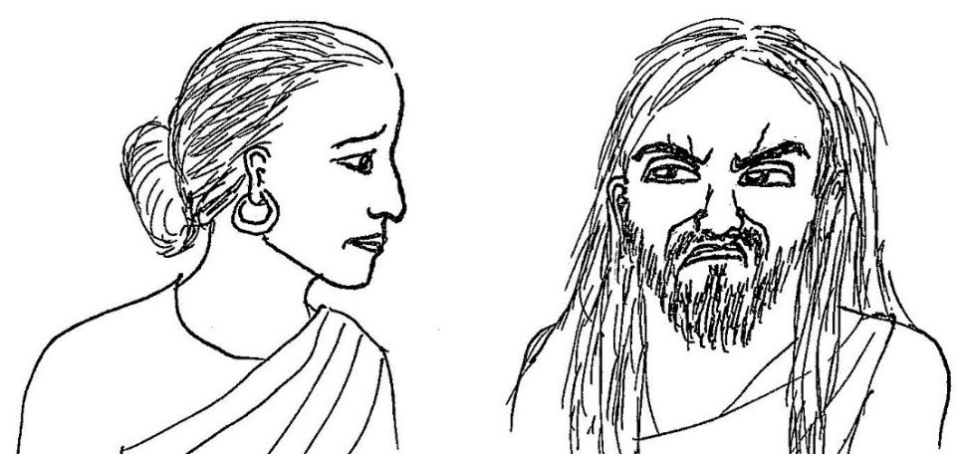

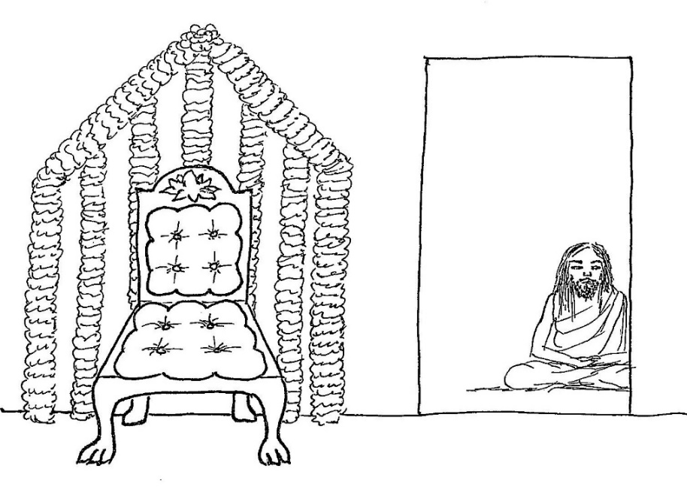

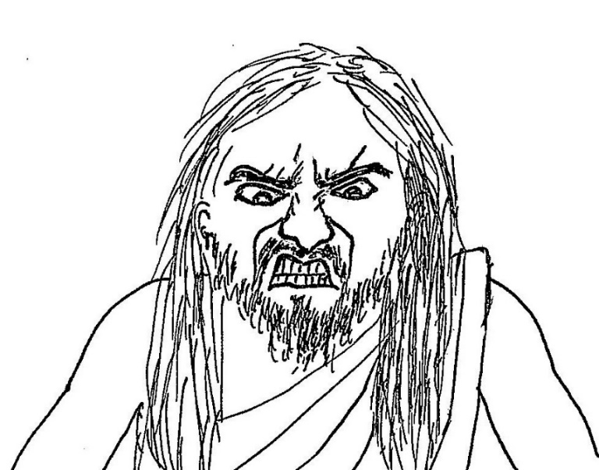

CHAPTER 3 – HOLY MAN MAKES A HORRIBLE SCENE

In the town of Savatthi lived a woman who was a devoted supporter of an ascetic—a man without a home and with very few belongings who is trying to become enlightened—named Pāțhika. She respected him as a holy man, so she prepared food for him every day and gave him whatever he needed as if he was her own son.

The Buddha was teaching in Savatthi at that time, and the woman’s friends and neighbors went to hear him teach. When they returned, they told the woman that the Buddha was the best teacher—so inspiring, so full of wisdom and knowledge, far greater than any other spiritual teacher they had ever heard of—and that he was able to make them truly understand the Dharma and transform their lives, leading them to real peace and deep happiness. They would often say,

“Oh, how wonderful is the teaching of the Buddhas!”

When the woman heard her neighbors praising the Buddha like that, she wanted to go to the monastery and hear the Buddha, too. Out of respect for Pāțhika, the ascetic she was supporting, she asked his permission to go and hear the Buddha. She said to him,

“Noble sir, I want to go and hear the Buddha.”

He responded, “Don’t go.”

She told him later, several times, that she wanted to go to the monastery and hear the Buddha teach. He responded each time by simply telling her not to go.

The woman thought to herself, “Since this ascetic will not permit me to go to the monastery to hear the Dharma, I will invite the Buddha to my own house and hear the Dharma right here.”

That evening, she said to her son, “Go and invite the Buddha to accept lunch from me tomorrow.”

The boy left the house to go to the monastery, but out of respect for the ascetic to whom his mother was so devoted, he went to visit Pāțhika first.

The ascetic asked him, “Where are you going?”
The boy replied, “By my mother’s instruction, I am going to invite the Buddha.”

Pāțhika said, “Don’t go to him.”

The boy responded, “Okay, but I am afraid of my mother, so I have to go. I am going.”

Pāțhika said, “Let the two of us eat the fine foods prepared for him. Don’t go.”

The boy said, “No, my mother will scold me.”

The ascetic had another idea, and said, “Well then, go. But when you go and invite the Buddha, don’t tell him where the house is, on what street it is, or what road to take to get there. Instead, act as if you live nearby, and when you leave, run off as if you intend to take a different road, and then come back here.”

The boy listened to these instructions and then went to the monastery. When he got an opportunity to approach the Buddha, he went up to him and invited him to lunch the next day. As directed by the ascetic, the boy didn’t tell the Buddha the address or directions to the house, and he left walking quickly in the direction of a road that didn’t lead to his house, and then went back to the ascetic.

When he arrived, Pāțhika asked him, “What did you do?”

The boy replied, “Everything you told me to do, noble sir.”

The ascetic said, “You have done very well. Now tomorrow the both of us shall eat the fine foods prepared for him.”

The next day, early in the morning, Pāțhika went to the woman’s house and, taking her son with him, sat down in the back room of the house.

The neighbors smeared the house with cow-dung, which was the traditional way of freshening up the house. Cow dung in those days in India was considered clean. According to the traditions in India for receiving very important guests such as kings, the neighbors hung strands of five types of flowers as decorations around the area where their honored guests would sit. They brought an expensive chair for the Buddha to sit in, as they didn’t know what type of seat to prepare for a Buddha. They admired him so much that they thought he should be treated like a king, and didn’t know that he should be given a simple, clean seat appropriate for a monk.

Meanwhile, early in the morning the Buddha took his bowl and outer robe and went straight to the woman’s house. He didn’t need directions, a street name or an address. Buddhas never need to be told directions or how to get to any place; they know the paths that lead to wherever they are going.

When the Buddha arrived in front of her house, the woman went out to greet him, and respectfully bowed down to him and led him into her house. She gave him the wonderful food she had prepared. When the Buddha finished his meal, the woman took his bowl, wanting him to speak some words of Dharma in appreciation for the meal.

She listened to the Buddha and, hearing his beautiful voice teaching the Dharma for the first time in her life, she was full of happiness. With great joy she applauded him, exclaiming suddenly, “Well said! Well said!”

Pāțhika, sitting in the back room, heard the woman’s applause and words of praise for the Buddha. He couldn’t stand to hear his own supporter adoring some other teacher. Why was she ignoring him and getting all excited over this monk? Fuming with rage and unable to control himself, he leapt up, entered the room where the Buddha was teaching, and announced loudly to everyone,

“She is no longer my student!”

Turning toward the woman, he exclaimed to her with contempt, “Hag, you are lost for applauding this man like that!”

He shouted that she was disloyal, disrespectful and neglectful to him and therefore she was a disloyal, rude and uncaring person. He bellowed that she was ignorant and foolish for running after other teachers whom she knows nothing about.

Then he angrily yelled out all kinds of insults to the Buddha. He accused the Buddha of stealing other teachers’ students, taking over villages, brainwashing and forcing men to leave their families to become his shaven-headed monks. He seemed to be venting all the anger and jealousy that he had been holding in his mind. Then he quickly left the woman’s home, still shouting insults.

The woman was extremely embarrassed by Pāțhika’s insulting words. When the Buddha continued teaching, her mind was so upset by Pāțhika’s terrible behavior that she couldn’t concentrate her attention on the Buddha’s teaching. The man whom she thought was a holy man, whom she had been supporting with such devotion and respect, had insulted her and shocked her with horrible behavior that was totally inappropriate for a holy man. And much worse, he had shouted insults to her precious and most respected guest, the Buddha, in her own home! She felt so ashamed.

The Buddha asked her, “Are you unable to fix your mind on my teaching?”

She replied, “Good and venerable sir, my mind is completely upset by the insulting words of this ascetic.”

The Buddha said, “One should not think about the talk of such an ignorant person; one should pay no attention to behavior of people like him. One should think about only what one himself has done and not done, one’s own good and bad deeds.”

Questions:

1. Why did the woman support the ascetic, giving him food and whatever he needed? (she respected him as a holy man)

2. Why do you think he didn’t want her to visit the Buddha? (he was jealous and wanted her only to support him and be loyal to him)

3. What did the ascetic plan to do when the woman would make good food for the Buddha the next day, and the Buddha doesn’t come? (eat the food that was prepared for the Buddha)

4. How did the Buddha know how to get to the woman’s house? (Buddhas always know the way to get to any place they are going)

5. How did the woman feel when Pāțhika insulted her and the Buddha? (shocked, embarrassed, ashamed)

6. What did the Buddha tell the woman not to think about, not to pay attention to? (the words and behavior of an ignorant person)

What the Buddha Said:

“Na parēsaṁ vilōmāni, na parēsaṁ katākataṁ, attanō va avekkheyya katāni akatāni ca.”
“One should not look into the faults of others, into things they did and did not do. One should instead consider what oneself has done and left undone.”

Dhammapada 50 (4:7)

Dharma discussion – Misbehavior of others:

Why was the woman in the story so shocked and embarrassed?
The ascetic, Pāțhika, was supposed to be her spiritual friend and teacher, and was a guest in her house, yet he behaved so terribly toward the Buddha.
She was shocked that someone whom she trusted and respected so much suddenly misbehaved so badly.
Maybe she felt foolish, betrayed or angry for having respected and supported him as a holy man for so long when now he seemed not to be very holy at all.

Think of a time when someone shocked you with their terrible misbehavior.
Can you remember your thoughts and feelings at that time?
Maybe you felt scared that the person might hurt you or someone else.
Maybe you worried that the person might damage something.
If the person bullied you or someone else, or said something insulting or disrespectful, maybe you felt angry or hateful or you felt like taking revenge.
If a friend or family member shocked you with their misbehavior, maybe you felt upset, embarrassed or ashamed, like the woman in the story.

The Buddha teaches us not to think about other people’s misbehavior.
But it’s difficult to stop thinking about it when it makes us have these feelings—these strong emotions—of fear, worry, embarrassment, shame, anger, hatred or vengeance.
So how can we stop thinking about their misbehavior?
First, we try to calm our emotions.
What do you do to help calm yourself down?
Maybe you like to read, listen to music, go outside, play with a pet, talk to a friend, draw a picture, or write in a journal.
You could also try mindfulness.
One way to practice mindfulness is to go to a quiet place, sit down and close your eyes, and pay close attention to everything you can hear and everything that your body is feeling.
Notice every little sound, but don’t think about it—what it is, where it came from—just keep listening.
Notice everything your body is feeling: for example, the chair or ground underneath you, the warmth of your fingers against each other, the warmth of your toes against each other, the air going in and out of your nose, the movement of your belly with each breath in and out, your eyelids against your eyes, your tongue against your teeth.

Next, when your mind wanders back to thinking about the person’s misbehavior, consider whether there’s an ongoing problem or danger with this person that you need to resolve.
Are you worried this person will misbehave again and harm you or someone else, or damage something?
If so, then think about what you reasonably can do to avoid harm or prevent the person from causing harm or damage in the future.
Or, are you feeling angry, thinking they should be punished for what they did?
Then consider whether you should report their behavior to an adult who can best handle any consequences for the behavior.
Once you’ve decided what you can do to avoid future harm or damage, or decided to report their behavior, then there’s no need to think about the misbehavior anymore. You have resolved the problem, there’s nothing more you can do, worrying more won’t help, so let it go!
You can let any revengeful thoughts go by remembering that the person will eventually suffer the results of their bad karmas, their bad deeds, and you don’t want to make bad karma for yourself by taking revenge, harming that person.

But, if you’re still thinking about a person’s misbehavior, then consider, is there anything you can learn from their behavior?
Think about whether you sometimes might behave in a similar way.
Maybe you don’t behave exactly like that person, but maybe you get overly upset or angry about certain things and snap at others occasionally.
Or, are you focusing on their misbehavior to make yourself feel like you are better than them?
Instead of thinking about their “bad,” think about your own “bad.”
You can remember this by pointing your finger and thinking: “When I point a finger at others, look at my other fingers pointing back toward myself.”
Also, at the end of the day, think of your behavior, what you did and said that day, and whether there is anything you could do better next time.
These are ways to practice what the Buddha taught, to look at your own behavior rather than that of others.

If you’re still thinking about the person’s misbehavior, ask yourself, “Is there is any other good reason to think about it?”
If not, then thinking about it is probably just dragging your thoughts down into negativity – you have more and more thoughts of fear, worry, anger, hatred or vengeance that aren’t helping you. This is what the Buddha is teaching us to avoid.
Whenever you think of the misbehavior, try to replace the negative thoughts with positive thoughts.
For example, try to feel compassion for the person who misbehaved, and wish them peace and happiness. If they were peaceful and happy, they wouldn’t misbehave.
Feel grateful that you don’t have circumstances like those that caused the person to misbehave.

Chapter 4 pictures

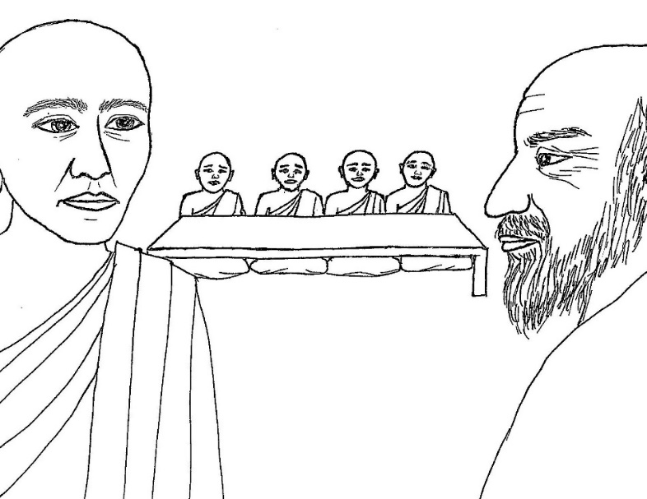

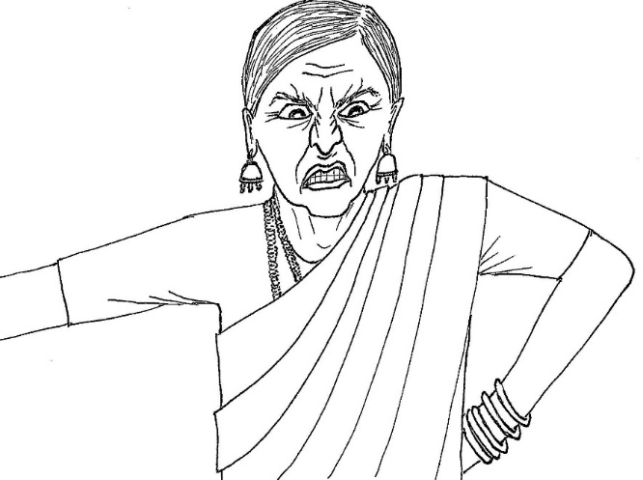

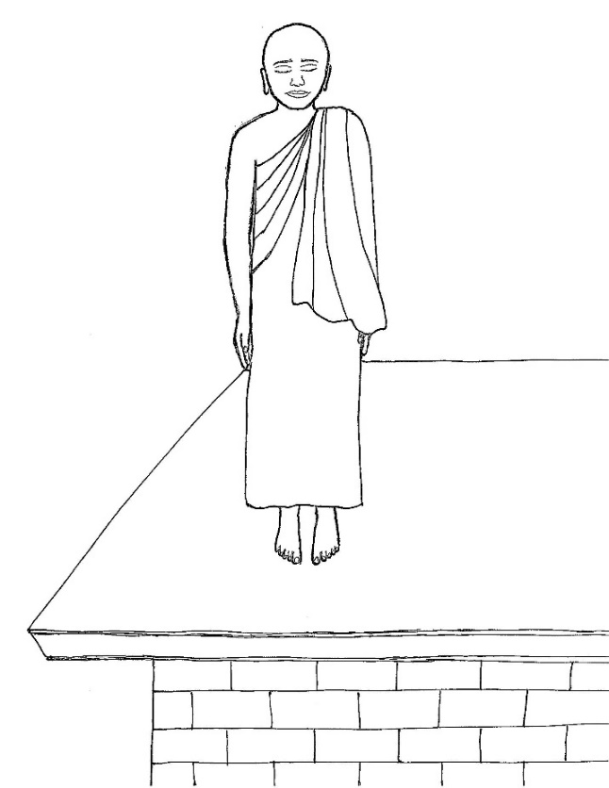

CHAPTER 4 – FOUR HUNGRY LITTLE MONKS

There was once an elderly, wealthy couple who were of the highest—or elite—level of society, called brahmins in India. Before the sun rose, the woman prepared delicious food that she wanted to offer to four monks, as a way to make merit, to ensure her family’s good future. However, she didn’t want just any monks to come. She wanted to serve very special, elite monks who had come from the brahmin level of society before becoming monks. Very early in the morning, she told her husband,

“Go to the monastery and have the manager pick out four old brahmins, and bring them here.”

Her husband went to the monastery where the Buddha’s monks were staying, and said to the person who appeared to be in charge of receiving guests, “Have four brahmins picked out for me and bring them to me.”

The person in charge went inside the monastery and soon came back to the woman’s husband, along with four young little monks, only seven years old. But, these monks were extremely special; they were arahants, fully enlightened.

The husband led the four little monks to his spacious, lovely house. His wife was waiting, looking forward to serving her carefully prepared food to the best, wise old monks. She had bought four very expensive chairs for the monks to sit comfortably, and had everything beautifully set up for her guests.

As soon as she saw these little monks walk into her house, she was so shocked and disappointed that her smile turned into a scowl. How could her husband fail to comply with her very simple request for old brahmins? After all the work she had done to prepare for wise, highly respected guests, he comes home with some little kids! It seemed like a cruel joke! Filled with rage, she pulled her husband aside and sputtered,

“You have gone to the monastery and brought back with you four youngsters not old enough to be your grandsons!”

There was no way she was going to let these little kids mess up her nice new chairs. She spread some cushions on the floor for them to sit on and said to them,

“Sit here!”

She was determined to serve her carefully prepared food to some noble old monks. She said to her husband,

“Brahmin, go and look out for some old brahmins and bring them here.”

Her husband quickly went back to the monastery and noticed an older monk standing nearby. It was Venerable Sariputta, one of the two greatest, most advanced and famous students of the Buddha. The husband invited him for lunch, saying,

“Come, let’s go to our house.”

Venerable Sariputta agreed, and the husband took his bowl, according to the custom, and led him to his home.

When they arrived, Venerable Sariputta saw the four young monks sitting quietly. He asked,

“Have these brahmins received food?”

The husband admitted, “No, they have received no food.”

Venerable Sariputta knew that food had been prepared only for four guests, so it wasn’t appropriate for him to join the little monks for lunch.

He said, “These brahmins sitting here ought to receive food. Bring me my bowl.”

Taking his bowl back from the husband, he left.

The wife wondered what happened, asking her husband, “What did he say?”

The husband told her what Venerable Sariputta said and that he simply left. The wife seemed not to notice or care that Venerable Sariputta identified the little monks as brahmins. She said,

“It must be that he didn’t wish to eat. Go quickly, look out for another brahmin and bring him here.”

The husband went back to the monastery and saw Venerable Moggallana, the other of the two greatest, most advanced and famous students of the Buddha. The husband invited him for lunch and brought him to his house. When Venerable Moggallana saw the four little monks, he also knew that food had been prepared for four guests. He said the same thing as Venerable Sariputta had said, and, taking his bowl, went immediately back to the monastery.
The wife said to her husband, “Well, these elder monks don’t wish to eat. Go around the brahmin neighborhood park and bring back with you a single, old brahmin.”

The little monks had not yet eaten anything that day. And they had eaten nothing since noontime the day before, because monks don’t eat anything after noon. Lunch was their only meal of the day. They were famished with hunger.

Because the little monks, being arahants, had such great merit and purity, a signal automatically was received by Sakka, the king of the Heaven of the 33 Gods, when he felt his seat suddenly become hot. Wondering what caused it, he saw that the young monks had were at the elderly couple’s house since early morning with nothing to eat, and that they were weak and exhausted.

Sakka thought, “It’s my duty to go there,” so he disguised himself as a very elderly brahmin, worn out by old age. He went to the brahmin neighborhood park and sat down in the most conspicuous seat, so he would be easily noticed.

When the husband saw him, he thought to himself, “Now my wife will be delighted.” He said to the old brahmin, “Come, let’s go to my home for a meal,” and led him to his house.

When the wife saw the old brahmin, she was delighted and spread several rugs and mats over one of the chairs to make him very comfortable, saying, “Noble sir, sit here.”

But when Sakka, disguised as the old brahmin, entered the house, he respectfully bowed to the four little monks and found a place to sit at the edge of the cushions where the little monks were sitting, and sat cross-legged on the floor.

The wife, noticing his behavior, thought his mind must be confused—maybe senile—from old age. She was furious that nothing was going according to her plan to serve food to honorable, wise brahmins, and that she now had a bunch of unworthy people in her house, expecting food from her.

She said to her husband, “For sure, you have brought a brahmin, but you have brought back with you one old enough to be your father. He is going around bowing to child monks young enough to be his grandsons. What use have we for him? Put him out!”
The husband grabbed the old brahmin first by the shoulder, and then by the arm, and finally by the waist, and tried his best to drag him out. But the old man refused to budge from where he sat. The wife said to her husband,

“Come, you take hold of one arm and I will take hold of the other.”

So they each took hold of one of the old man’s arms, grabbed him around his back, and dragged him through the door out of the house. They walked back inside. But to their horror, the old man was sitting next to the young monks in the place he had been sitting before, waving his hands back and forth!

It seemed like some kind of magic, so they screamed in terror. At that moment, the old man let them know who he really was—Sakka, the king of heaven. The husband and wife were silent with shock and embarrassment and quickly served the food to this wondrous being from another world, along with the four young monks.

They ate the food and then quickly left. Three of the little monks left through the roof, one breaking through the front part of the roof, the other through the back part of the roof, and the other through the circular top of the roof. The fourth monk plunged into the earth to escape the house. Sakka used another way to escape. Because the young monks were arahants and Sakka was a powerful heavenly being, they all had supernatural power to move through solid surfaces. People in the town later heard about the monks’ spectacular exit, and from that time on, although the house was not damaged, it was known as the “House with the Five Openings.”

The young monks walked back to the monastery, and when they arrived, the other monks asked, “Friends, what was it like?”

The young monks replied at first, “Please, don’t ask.” But then they explained, “The wife fumed with rage the moment she saw us. She refused to allow us to sit on the seats she had prepared and said to her husband to quickly bring an old brahmin. Our teacher, Venerable Sariputta, came and seeing us, said, ‘These brahmins sitting here ought to receive food.’ So he ordered his bowl to be brought back to him and then left. Then the wife said to bring another old brahmin, and the husband brought Venerable Moggallana. When he saw us, he said the same thing as Venerable Sariputta said and left. Then the wife said to her husband that these venerable monks don’t want to eat, so go to the brahmin neighborhood park and bring a single old brahmin. The husband went there and brought back Sakka, who came in the disguise of a brahmin. When Sakka arrived, the husband and wife gave us food.”

The other monks said, “But weren’t you angry with them for what they did?”

The young monks replied, “No, we weren’t angry.”

When the other monks heard their reply, they couldn’t believe the monks weren’t angry in that situation. They didn’t know the young monks were arahants. So, they went to the Buddha, saying,

“Lord, when these monks say, ‘We were not angry,’ they are not telling the truth. They are being dishonest.”

The Buddha said, “Monks, those who have gotten rid of the poisons of the mind have no ill will toward those who are hostile to them. He who is friendly among those who are hostile, who is peaceful among those who are violent, who is detached among those who are attached, that person I call a brahmin.”

The Buddha was pointing out that those who should be most respected and called brahmins are not those who are in wealthy or elite families, but those who have great qualities.

Questions:

1. What was the wife overly attached to, that motivated her to neglect the little monks and drag the old man out of her house? (her high-class status as a brahmin, and her desire to serve only brahmins)

2. What was special about the four little monks? (they were arahants, enlightened)

3. Why did Venerable Sariputta and Venerable Moggallana leave without eating? (they knew that the wife had prepared food for only four guests)

4. How did Sakka, in a heaven-world, become aware of the hungry little monks? (he felt his seat become hot)

5. What was unusual about Sakka’s behavior, that made the wife upset? (he bowed to the young monks and sat on the floor rather than in the chair she offered)

6. What did the other monks not believe about the young monks? (that they didn’t get angry)

What the Buddha said:

“Aviruddhaṁ viruddhēsu, attadaṇḍēsu nibbutaṁ, sādānēsu anādānaṁ, tam ahaṁ brūmi brāhmaņaṁ.”
“He who is friendly among the hostile, who is peaceful among the violent, who is unattached among the attached, that person I call a brahmana.”

Dhammapada 406 (26:24)

Dharma discussion – When others are hostile:

What do you think of the couple’s behavior toward Sakka?
It was rude, disrespectful, hostile, and abusive!
They invited an old man for a meal at their house and then refused to give him food and dragged him out of the house only because he bowed to young monks and sat on the floor!
By the way, Sakka did that because kings, even kings in heaven-worlds, bow to monks and show their humility to them, because the Buddha and his monks, who represent the Buddha and are on the path to enlightenment, are more worthy of respect than kings.
And how did the wife behave toward the young monks? Neglectful, uncaring, impolite.

Are you sometimes around people who are very rude, disrespectful, hostile or abusive?
Especially nowadays, there are many people like that everywhere – in schools, in families, in all kinds of places, all over the world.
Why? It’s mostly because many more people have become extremely self-centered—selfish, egoistic—and don’t care about good values like compassion, humility, tolerance, patience, self-control and so on.

If someone is very rude to us, we don’t have supernatural powers like Sakka and the young monks to escape them or shock them into respecting us.
But we do have the power of the Dharma, like the young monks, to protect us from trouble.
How did the young monks use the power of the Dharma?
They stayed calm, and didn’t get angry or impatient at the couple for being rude and neglectful.
They remember they are following the Dharma and don’t get involved in people’s craziness.

But isn’t it a sign of weakness to just be quiet, not to stand up for oneself, not to point out to others when they are doing wrong?
In some situations–such as to prevent you or someone from getting harmed or abused, or when there is a significant injustice—it’s important to point out a person’s wrongdoing, to protect yourself and others.
We should try to be careful not to shame or insult the person, as that may just make them enraged and vengeful.
However, we don’t want them to get away with their bad behavior by saying nothing, because that could encourage them to do it again.
When we are hostile and quarrel, bicker or even fight or get violent over things that are unimportant, then we create negative karma that ends up harming us.
Even if we don’t naturally behave that way, when others around us—friends, classmates, neighbors, even family members—often get angry over petty things, then it seems normal and then we might start behaving a bit more like that, too.
The more we see anger, hostility, and aggressive behavior, the more it seems to be normal.
The more others insist on getting whatever they want, the more normal it seems for us to insist on getting whatever we want.

The Buddha teaches us to watch out for that.
He warns us that the people all around us may be hostile, violent, or too attached to things.
But we shouldn’t get caught up in that behavior, thinking it’s okay because it’s normal.
Remember, there are many people all around the world who follow the Dharma and stay strong with good values of compassion, lovingkindness, patience, tolerance, and so on.
The Dharma is what keeps us out of trouble, keeps us from falling into bad karmas—negative actions, words and thoughts.
We may feel anger, we may be upset when someone is unfair, we might feel disgust seeing someone misbehave, we may feel frustrated when they don’t get punished.
But we don’t let ourselves go down to their level of speaking and acting.
We can avoid behaving like they do by remembering the little monks—although we can’t fly through a roof, we have that same super power of the Dharma to keep us out of trouble.

How do we do that? How do we keep our mind out of trouble when we can’t escape people who are disrespectful, hostile, or abusive, when we have to be near them, for example, in class?
We may hate seeing, hearing or being around them and wish they would be punished.
We may even feel they are horrible people, and hate them.
But we should try to remember not to hate the person, just hate the behavior.
Also, notice, how do you feel when you have angry or hateful thoughts?
Stressed, upset, irritable, or depressed. So, these thoughts harm us; we don’t want them.
And, think about how people who are disrespectful, hostile, or abusive must feel.
Although they may laugh, smile, and act confident, they’re not really happy and peaceful.
If we really knew what they experienced at home or in their past, we might see that their behavior is a result of abuse, neglect, violence or other bad behavior of their parents.
They may be imitating their parents’ aggressive way of speaking and behaving, maybe as a way to get approval and love from the parents.
So, we can try to have compassion, because we don’t know what their life is like at home, or what happened in their past—the causes and conditions that make them misbehave.
Remember, they will have to suffer the results of their bad karmas, their negative actions.
They weren’t as fortunate as we are to learn the Dharma.
We can wish that they be happy and peaceful and learn the Dharma soon.
This helps keep us calm, positive, strong and out of trouble even in a negative environment.
Also, we can be friendly with them, for example, we can kindly tell them that we hope they enjoy the rest of their day, or say something funny (but not insulting) to distract from negativity.

Chapter 5 picture

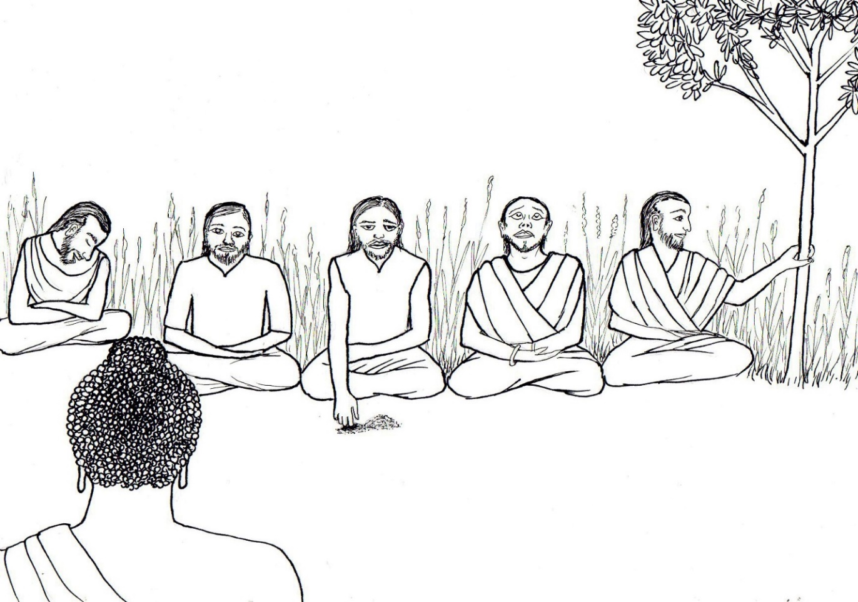

CHAPTER 5 – BORED WITH THE DHARMA

There were five men who went to the monastery wanting to hear the Dharma. They heard that the Buddha was a great teacher of the Dharma, and they knew that hearing the Dharma was a good karma that would help give them a good future. They bowed respectfully to the Buddha and sat down.

The Buddha began to teach the Dharma. Buddhas don’t teach to entertain, nor do they teach in order to make anyone feel special or exceptional regarding their wealth or social status, because it might increase their attachments to things in the world or increase their ego or self-centeredness. Buddhas teach so people will have great respect for the Dharma, so that they learn ways to reduce their attachments, calm and purify their minds, and reach enlightenment.

The Buddha’s teaching didn’t make the men laugh or feel proud of themselves, and didn’t tell thrilling stories. So, it wasn’t interesting enough to keep one of the men awake, and he gradually became very sleepy. As he sat there, his eyes closed and his head began to nod. Soon, his chin was resting on his chest and he fell asleep.

The second one of the five began to stroke the earth with his finger, making designs on the soil. Then he made deeper lines in the soil. And finally, he began to dig deeper in the soil with his finger. The earth felt so nice and cool against his fingers.

The third of the five men was sitting near a small tree. He pushed gently against the tree to see if it would bend. Then he pushed harder, and felt it bend a little. Then he grasped the tree trunk in his hands and pushed it back and forth to make the leaves rustle slightly. He liked the sound of the rustling leaves, and shook the tree more to make the leaves rustle.

The fourth of the five men noticed an interesting cloud in the sky. Then he saw the moon. The sun was starting to go down, so he gazed all around the sky to see if he could find any stars shining. He loved to look at the sky.

The fifth man was different. He wasn’t distracted like the others, but was very alert. He listened with full attention to the Dharma teaching.

Venerable Ananda was observing the five men. He stood next to the Buddha, fanning him to keep him cool and keep insects away. He said quietly to the Buddha,

“Lord, you are teaching the Dharma so clearly and powerfully, like the thunder during a heavy rain. But even as you are teaching, only one of these men was listening attentively. The others were sitting there sleeping, playing with the soil, fidgeting with a tree, or looking up at the sky. Why are they behaving this way?”

The Buddha asked, “Ananda, do you know these men?”

Venerable Ananda replied, “No, Lord, I don’t.”

The Buddha said, “Of these five men, he that sits there sound asleep had five hundred past lives as a snake, and in each of those lives he coiled his body, laid his head on his coils and fell asleep. Therefore, now he is sound asleep. Not a sound I make enters his ear.”

Venerable Ananda was curious, and asked, “But, Lord, tell me, were these five hundred lives one right after the other, or was he a snake in some lifetimes and then reborn as another type of being in between the lifetimes as a snake?”

The Buddha replied, “Ananda, at one time this man was reborn as a human being, and another time as a god in a heaven-world, and at another time as a snake. Indeed, it would be impossible to determine exactly the number of times he has been reborn in each of these forms. But in five hundred lives one right after the other, he was born as a snake and fell asleep. Not even yet does he feel satisfied with enough sleep.”

The Buddha continued, “The man who sits there scratching the earth with his finger had five hundred past lives, one after another, as an earthworm and burrowed into the earth. So, he digs the earth now also, and doesn’t hear my voice.”

“The man who sits there shaking a tree had five hundred past lives, one after another, as a monkey, and from the habit of monkeys that he had in those past lives, he still continues to shake a tree, and the sound of my voice does not enter his ears.”

“The brahmin who sits there gazing at the sky had five hundred past lives, one after the other, as an astrologer, and therefore today he gazes at the sky just the same, and the sound of my voice does not enter his ears.”

A brahmin is a man of the upper class, the highest level in society. An astrologer is a person who tells people about their future based on information about the planets, sun and moon.

The Buddha said, “The man who sits there listening attentively to the Dharma had five hundred lives, one after another, as a brahmin who had knowledge of the Three Vedas, and was devoted to studying and reciting those ancient holy teachings of India. Therefore, he listens attentively today also, as though he were putting together a holy scripture.”

Venerable Ananda still couldn’t understand why the four men wouldn’t be fascinated with the Dharma teaching that he could so clearly understand and enjoy. He said,

“But Lord, your teaching of the Dharma absorbs into the skin and even inside the bones. Why is it that while you are teaching the Dharma, they don’t listen attentively?”

The Buddha replied, “Ananda, you evidently imagine that my Dharma is easy to listen to.”

Venerable Ananda said, “Lord, do you mean that it is difficult to listen to?”

“Exactly so, Ananda.”

“Why is that, Lord?”

“Ananda, these living beings, during countless thousands of cycles of time, never heard of the Buddha, the Dharma and the Sangha and therefore are unable now to listen to this Dharma I teach. In all the countless lifetimes—we cannot imagine how long ago they began—these living beings were used to listening to the speech of animals of all kinds. Therefore, they spend their time in places where men drink and amuse themselves, and sing and dance. It is impossible for them to listen to the Dharma.”

Venerable Ananda still didn’t understand, asking, “But Lord, for what reason is it that they are unable to listen to the Dharma?”

The Buddha answered, “Ananda, they are unable to do so by reason of desire and craving, hatred and delusion. There is no fire like the fire of desire, which burns up living beings without even leaving any ashes. The world-fire which finishes off an eon of time burns up the world without leaving anything behind, but it is a fire which breaks out only on the appearance of the seven suns, and this fire burns only at certain times. But as for the fire of desire, there is no time when the fire of desire doesn’t burn. Therefore I say that there is no fire like the fire of desire, no grip like hatred, no trap like delusion, and no river like craving.”

Questions:

1. Why did the five men go to the monastery? (they wanted to hear the Dharma, they knew hearing the Dharma was good karma and would help give them a good future, and heard that the Buddha was a great teacher)

2. Why, according to the Buddha, did the first man fall asleep? (he had five hundred past lives as a snake, and would coil his body and fall asleep)

3. Why, according to the Buddha, did the second man dig in the soil? (he had five hundred past lives as an earthworm)

4. Why, according to the Buddha, did the third man shake the tree? (he had five hundred past lives as a monkey)

5. Why, according to the Buddha, did the fourth man gaze at the sky? (he had five hundred past lives as an astrologer)

6. What was the fifth man interested in during five hundred past lives? (studying and reciting the ancient holy teachings of India)

What the Buddha said:

“Natthi rāga samo aggi, natthi dosa samo gaho,
natthi moha samaṁ jālam, natthi taņhāsamā nadi.”
“There is no fire like desire, no grip like hate, no net like delusion, no river like craving.”

Dhammapada 251 (18:9)

Dharma discussion – Habits and the Three Poisons:

This story tells us a lot about past lives. What did you learn from the story about past lives?
We have had so many past lives that we cannot count them.
We likely have had many, many past lives as animals and as humans.
We might have habits now that come from our past lives as animals or our past human lives.
If we are able to listen to the Dharma now, we had past lives learning spiritual teachings.
And those who in past lives didn’t learn much spiritual teaching, or about the Buddha or Dharma, are not interested in the Dharma now.
But does that mean they are bad or unimportant? No! We too were like that in past lives! Everyone goes through lifetimes like that.
We can have compassion for people who aren’t interested in the Dharma, because they haven’t yet found the path to end all suffering, and we were once like that in the past.

What if we see people falling asleep or fidgeting during a Dharma talk—can we assume they’re not listening to the Dharma, or not interested in it? No.
We can’t judge people based only on what we see. People may be listening very carefully to the Dharma even if their eyes are closed or they are fidgeting or appear distracted.
Or, a person might just be very tired or unable to concentrate for some reason during a particular Dharma talk.

Those of us who pay attention to stories of the Buddha and Dharma discussions most likely enjoyed them in past lives too. And this is extremely special and fortunate!
This is because most people, like those in the story, are not interested in the Dharma.
It’s only because we have a lot of good karma—we made a lot of merit—plus we had an interest in spiritual teachings in past lives that we are interested in the Buddha now.

Why do people not listen to the Dharma when they had no past lives, or only a few, learning spiritual teachings?
They have so much delusion and desire, craving and hatred in their minds that they think that just fulfilling their desires will make them happy.
Desire, hatred and delusion are called the Three Poisons in Buddhism.
Desire also includes greed, craving, and attachment to things that don’t lead to wisdom.
Hatred also includes disgust, anger and aversion, which means dislike.
Delusion includes ignorance, confusion, not having wisdom, not knowing.

Why are they called the Three Poisons?
Because they cause suffering and death, like poison causes suffering and death.
The Three Poisons cause all types of suffering, so they are also called the roots of suffering.
What do we mean by “suffering” in Buddhism?
It’s not only the extremely painful feeling or terrible grief that we usually think of as suffering, but also any unpleasantness—any kind of dissatisfaction, distress, worry, fear, disappointment, frustration, anxiety, unhappiness or discomfort.

How can desire, hatred and delusion cause all suffering?
When we desire something, then sometimes we don’t get it, can’t have it, it breaks, or we lose it or get bored with it, so we feel dissatisfied, disappointed, unhappy, or upset—we suffer.
When we hate or dislike something, it may be hard to avoid it or get away from it, which makes us feel uncomfortable, anxious, distressed, angry, worried, or afraid.
With ignorance—when we don’t have wisdom—then we have so many desires for things in the world that we think will make us happy, and there are so many things we don’t like and try to avoid, so then we have all kinds of negative emotions such as frustration or anger when things don’t go our way.

Doesn’t everyone have some desire, hatred and delusion? Yes, until we become enlightened.
And some desires and aversions are necessary—we desire food, clothes, friends and a home, and we hate feeling sick, hungry, too cold or too hot, so that we keep ourselves healthy.
But when we have too many unnecessary things that we desire and hate, then we suffer more.
Of course, we can’t easily get rid of our desires like throwing them in the trash.
But we try to be aware of them, and notice when they bother us, for example, when we get upset or angry about not getting what we want or when we lose what we are attached to, and when we feel irritable or angry thinking about something or someone we hate.
And we try to remember that the less desires, hatred and delusion we have, the less we suffer, and the more peaceful and happy we become.
And we try to reduce them. How do we do that? By learning and practicing the Dharma.
We practice the Dharma by developing good habits and reducing our bad habits.

In Buddhism, what do we mean by “bad habits”?
Habits that cause harm to ourselves or others, that cause more negative emotions—such as more anger, hatred, jealousy, greed, arrogance, or selfishness.
It doesn’t mean harmless habits, like those in the story—digging in the dirt, shaking trees, gazing at the sky, or sleeping. Those were only indications that the men weren’t listening.
Can you think of some examples of bad habits?
Fighting, quarreling, bullying, insulting others, being too critical of others, lying, being dishonest, following others’ misbehavior, showing off, buying things you don’t need, insisting on having what others have, taking things that weren’t given to you, playing too much videogames, and watching violent videos, or too much TV, social media, or unwholesome things on internet.

What are “good habits,” according to Buddhism?
Habits that develop our good qualities, such as lovingkindness, compassion, generosity, patience, tolerance, awareness and wisdom.
Can you think of some examples of good habits?
Helping others, being considerate and aware of what others might need, letting others go first, being honest, thanking others, complimenting others, appreciating others’ success and good qualities, meditation, prayers before bed, practicing mindfulness, and having self-discipline with videogames, TV, videos, and using internet.

As we learned in the story, we tend to keep our strong habits even in our future lives.
So, what should we do about our good and bad habits, to have a good future?
We start good habits, make our good habits stronger, avoid starting bad habits, be aware of our bad habits, and try to reduce and control them.

Chapter 6 pictures

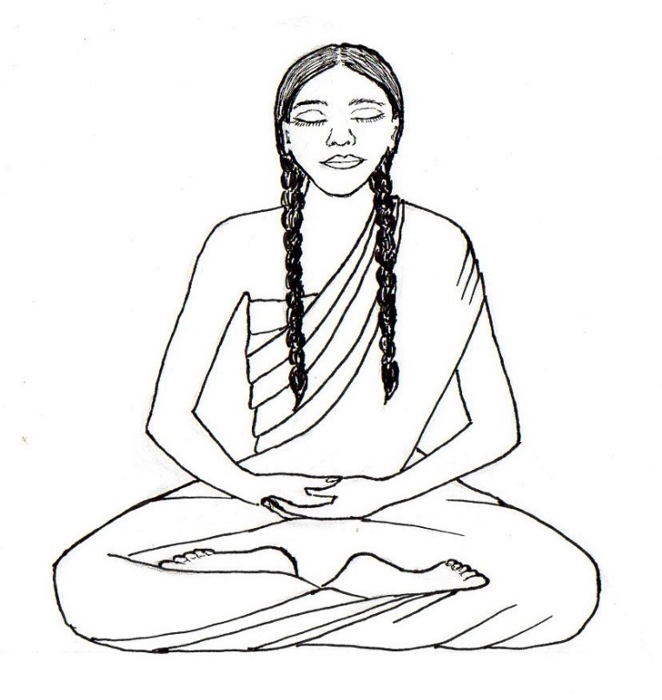

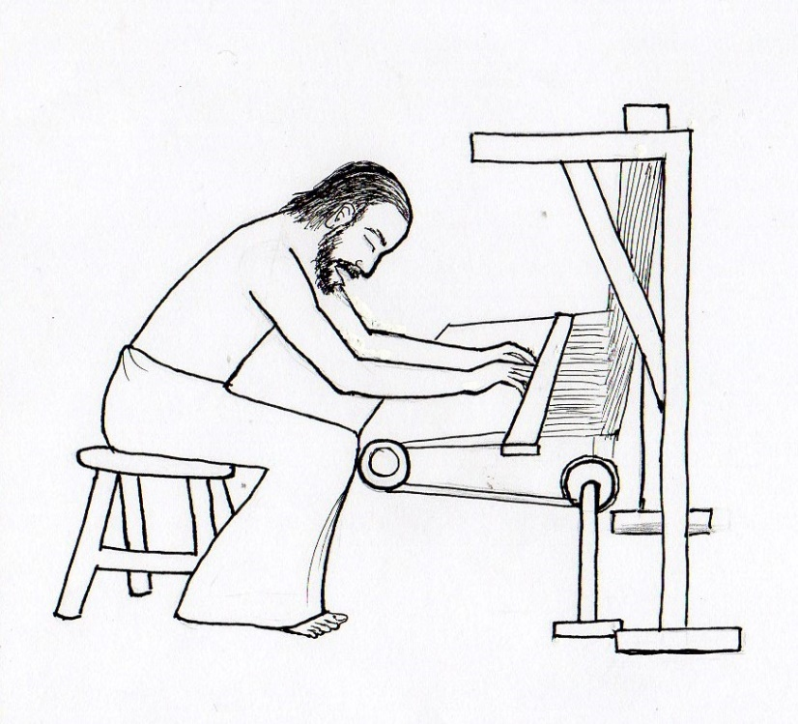

CHAPTER 6 – THE WEAVER’S DAUGHTER

One day, the Buddha went to a town called Alavi where some families invited him to a meal and made offerings. At the end of the meal, as usual, the Buddha gave a Dharma talk. The subject of the Dharma talk was impermanence. He instructed the people to meditate on impermanence—that everything in the world, including our life, comes to an end; we all must pass away at some point. He said that people who meditate on impermanence will have no fear when their life comes to an end.

During the Dharma talk, all the people there kept thinking about their jobs, responsibilities and plans at home with their families and friends, which was their usual habit. They weren’t really paying attention to what the Buddha was saying.

But there was one exception. A sixteen-year-old girl who was the daughter of a weaver, a man who made cloth by weaving it on a loom, was listening very carefully and clearly understood what the Buddha was saying. She thought to herself,

“Marvelous is the speech of the Buddhas. I must practice meditation on impermanence.”

So, she diligently practiced meditation every day, in the daytime and in the night. Meanwhile, the Buddha traveled back to Jetavana, his monastery near the town of Savatthi.

Three years later, one early morning before sunrise, the Buddha as usual observed the world from his mind—his inner eye—and he became aware of this girl, the weaver’s daughter. He thought to himself, “What will happen?” He became aware that from the day when the girl heard his Dharma talk, she meditated on impermanence every day for three years. He thought, “I will now go back to Alavi and ask this girl four questions. On each of the four she will answer me correctly, and I will congratulate her. I will then give a few words of teaching beginning with the words, ‘This world is indeed blind.’ As soon as she hears these words, she will reach the first level of enlightenment. Because of her, my Dharma talk will be helpful to the crowd of people there, too.”

The Buddha along with a few hundred monks, departed from Jetavana and walked a hundred miles to the monastery in the town of Alavi. When the people of Alavi heard that the Buddha had come, they invited him to be their guest for meals in the next days. The weaver’s daughter also heard that he had come, which filled her heart with joy. She thought,

“Here has come, so people say, one that is my father, my master, my teacher, one whose face is bright like the full moon, the mighty Gautama Buddha. Now, for the first time in three years, I will see the Buddha, whose body is the color of gold. Now I am permitted to see him, and to hear him preach the wonderful Dharma, which contains all sweetness.”

But her father, on his way to the workshop where he would work weaving cloth on his loom, said, “Daughter, an item of clothing for a customer is on the loom, and part of it isn’t yet finished. I must finish it today. Quickly get more thread on the spool and bring it to me.”

The daughter thought, “It was my dream to hear the Buddha teach the Dharma, but my father has asked me to do this. Should I hear the Buddha teach the Dharma or get more thread and carry it to my father? If I don’t bring my father the spool of thread, he will hit me and beat me. Therefore, I will first bring the thread and give it to him, and wait until afterward to hear the Dharma.”

So she sat down on a stool and began winding the thread around the spool to load it for her father.

Meanwhile, the people of the town of Alavi offered the meal to the Buddha and his monks, and when the meal was finished, the people took his bowl and stood waiting for him to speak some words of appreciation, rejoicing in their merits for providing the meal and other offerings.

The Buddha said, “I came here on a journey of one hundred miles for the sake of a certain young lady. She hasn’t yet found an opportunity to be here. When she can be here, I will speak the words of rejoicing.”

He then sat down and remained silent. When the Buddha is silent, no one dares to make a sound. So, everyone around him just stood or sat silently.

When the weaver’s daughter had loaded the spool with thread, she put it in her basket and started walking in the direction of her father’s workshop. On her way, she stopped and stood in the outer circle of the crowd of people silently standing around the Buddha, waiting for him to speak. She stood there, gazing at him.

The Buddha lifted his face up to look over the crowd and then his eyes met hers. As he gazed at her, he thought, “If this young lady leaves, she will die as an ordinary person and her future birth will be uncertain. But if she comes to me, she will leave this Earth established in the first level of enlightenment, and her future will be certain—she will be reborn in the Heaven of the Thirty-three Gods.” He knew that her karmic energy to maintain her human body was going to disappear very soon, so her destiny was to die that day and there was no possibility for her to avoid it.

The weaver’s daughter didn’t know what he was thinking, but she knew what he wanted her to do. By his way of looking at her, she thought, “The Buddha, sitting in such a crowd, signals by gazing at me that he wants me to come, he only wants me to go up to him.”

So, she set her basket on the ground and walked through the large group of people toward the Buddha. She approached closer, walking through the rays of six colors of light radiating from his body, that ordinary people could not see. She bowed to him and stood respectfully at one side.

Immediately he said to her, “Young lady, from where do you come?”

She answered, “I do not know, Lord.”

He asked, “Where are you going?”

She replied, “I do not know, Lord.”

He asked, “Do you not know?”

She answered, “I know, Lord.”

Then he asked, “Do you know?”

She said, “I do not know, Lord.”

These were the four questions that the Buddha knew earlier that he would ask. He was pleased with her answers, but was silent about it. The crowd of people, however, were offended by her answers. They thought she was being foolish or silly.

They whispered among themselves, “Look, this daughter of a weaver talks as she pleases with the Supremely Enlightened One. When he asked her ‘From where do you come?’ she should have answered, ‘From the weaver’s house.’ And when he asked her, ‘Where are you going?’ she should have answered, ‘To the weaver’s workshop.’”

The Buddha wanted to show the crowd that she was not arrogant, ignorant or being disrespectful, as they thought she was. So he asked her,

“Young lady, when I asked you, ‘From where do you come?’ why did you say ‘I do not know’?”

She replied, “Lord, you yourself know that I came from the house of my father, a weaver. So when you asked me ‘From where do you come?’ I knew very well that you meant ‘From where did you come before you were born here?’ But as for me, from where I came when I was reborn here, that I do not know.”

Then the Buddha said to her, “Well said, well said, young lady! You have answered correctly the question I asked you.”

Then he asked her, “When I asked you, ‘Where are you going?’ why did you say ‘I do not know’?”

She responded, “Lord, you yourself know that I was going to the weaver’s workshop with the spool of thread in my basket. So when you asked me, ‘Where are you going?’ I knew very well that you meant ‘When you pass away, where will you be reborn?’ But as for me, where I will be reborn when I have passed from this present life, that I do not know.”

Then the Buddha said to her, “You have answered correctly the question I asked you.”

In that way the Buddha congratulated her for the second time, and then he asked another question, “When I asked you, ‘Do you not know?’ why did you say, ‘I know’?”

She said, “Lord, this I know, that I shall surely die; and therefore I said so.”

Then the Buddha said to her, “You have answered correctly the question I asked you,” congratulating her for the third time. Then he asked,

“When I asked you, ‘Do you know?’ why did you say ‘I do not know’?”

She replied, “This only do I know, Lord, that I shall surely die; but at what time I shall die, whether in the night or in the daytime, whether in the morning or at some other time, that I do not know and therefore I said so.”

The Buddha said, “You have answered correctly the question I asked you.”

Then, speaking to the crowd of people, he said, “Those among you who failed to understand the words she spoke, only you were offended. For those who don’t have the eye of understanding, only they are blind; those who have the eye of understanding, only they see.”

He therefore let the crowd know that they were the ones who were blind, and couldn’t see the truth—in other words, they were the ones who were ignorant—and not the girl. He spoke the following verse,

“This world is indeed blind. Few are those who deeply see. Like birds escaping from a net, few will go to a blissful heaven.”

He meant that most people in the world are ignorant and can’t understand the Dharma; only a few people can understand it and reach the higher heaven-worlds after they pass away. At the end of the Dharma talk, the weaver’s daughter had reached the first level of enlightenment. She took her basket and went to her father in the workshop.

He was asleep sitting in the chair in front of the loom. She didn’t notice he was asleep, and she handed him the basket. As she did so, the basket hit the tip of the loom and then the basket fell with a clatter onto the floor. As her father was startled and woke up suddenly, he grabbed hold of the loom, pulling it, and by accident, the tip of the loom swung around and hit his daughter in the chest.

Right then and there she died from the impact of the heavy loom. She was reborn in the Heaven of the Thirty-three Gods.

Her father looked at her as she lay there and saw that she had died.

Immediately, intense grief arose in him. Thinking of the Buddha, he wailed, “There is none other that can take away my grief,” and then he went to the Buddha and, telling him what happened, cried, “Lord, take away my grief.”

The Buddha comforted him, saying, “Don’t grieve, my student; in the cycle of lives without any imaginable beginning, you have also cried over the death of your daughters, with more tears than the water contained in the four oceans.”

The Buddha then gave a Dharma teaching on the cycle of countless lives without any imaginable beginning. Hearing him speak, the weaver’s grief was calmed. He requested the Buddha to allow him to be ordained as a monk. He became a monk and not long afterward became an arahant, reaching enlightenment.

Questions:

1. In the beginning of the story, who in the crowd was paying attention to the Dharma talk? (only the weaver’s daughter)

2. What did the weaver’s daughter do daily after the first time she heard the Buddha speak? (she practiced meditation on impermanence every day and night)

3. When the Buddha returned to Alavi, what did the girl decide to do first, get the thread for her father or hear the Dharma? (get the thread for her father)
4. What did the Buddha do while the girl was getting the thread? (ate his meal and then sat silently and waited for her to arrive)

5. What did the people think about the girl’s responses to the Buddha’s questions? (they thought she was ignorant, arrogant or being disrespectful; being foolish or silly)

6. What did the Buddha mean when he said “The world is indeed blind. Few are those that deeply see”? (most people are ignorant and can’t understand the Dharma; only a few people can understand it and reach the higher heaven-worlds after they die)

What the Buddha said:

“Andha bhūto ayaṁ loko, tanuk’ ettha vipassati, sakunto jāla mutto ‘va, appo saggāya gacchati.”
“Blind is this world. Few are those who clearly see. As few birds escape from a net, few go to a blissful state.”
Dhammapada 174 (8:7)

Dharma discussion - Lovingkindness and Wisdom:

How did the Buddha show his lovingkindness to the weaver’s daughter?
He walked 100 miles just to see her and teach her so she could reach the first level of enlightenment before she died. He did this even though he could have visited thousands of other people instead without traveling far, or could have stayed with his monks at Jetavana.

What is lovingkindness? Why don’t we just say “love” or just say “kindness”?
Because sometimes we might love someone but not show kindness to them,
Or we might be kind to someone but not feel any love for them.
Lovingkindness means love plus kindness.
It means kindness in body, speech and mind: kind thoughts, kind words, kind actions.
What does this look like in our daily life?
We are friendly, we help others, we use kind words, we say prayers for others to be happy, we think of the needs of others and not just ourselves.

Lovingkindness means we truly care about a person, wishing for their happiness and well-being.
We’re friendly and helpful to others because we honestly care about them, and not because we’re trying to get something in return—some kind of reward, or admiration, or attention.
The Buddha didn’t act friendly and helpful to become popular, be admired, or receive food.
Instead, he went where at least one person would understand and benefit from his teachings. He traveled and helped people only for their happiness.
Lovingkindness means we help others for their benefit, for their happiness, and not just because we want them to like us or be our friend.

But is it so simple—just be friendly and help others all the time?
We can’t always help everyone, especially if we have other responsibilities.
Even the Buddha didn’t visit or talk to everyone just to please them.
With his wisdom, he knew who he could help the most to reach enlightenment, and used his time wisely to talk to those people.
Similarly, we use our wisdom to choose the situations where it’s most reasonable for us to help.
That means we set priorities—we choose what is most important and do those things first.
In the story, the girl had to choose what to do first—hear the Dharma or help her father.
He needed the thread for his job right away, and she decided to help him first.
Still, she really wanted to see the Buddha first on her way to her father. Then, when the Buddha signaled for her to come to him, that took priority over helping her father.

Another reason lovingkindness isn’t so simple is that some people can abuse our kindness.
They “use” us—in other words, they exploit us, take advantage of our kindness—by asking us for something they want, or asking us to do something for them, for selfish reasons.
They might ask us because they’re lazy or greedy, or to show they have power over us, or to bully us. Or they may ask us to do something they don’t want to do, or that’s wrong (for example, a classmate asking us to let them copy our answers on a test or schoolwork).
If we do what they want, then are we really helping them in a good way?
No. Doing what they want rewards them for being selfish, and encourages them to use us and use others even more. Then they are creating bad karma.
To avoid this, we shouldn’t automatically give or do something just because they ask.
Instead, use your wisdom by asking yourself, why is the person asking me—is it because they are selfish or manipulative? If so, or if you don’t feel good about it, then don’t do it.
Does that mean you’re being unkind?
No. Lovingkindness means we truly care about others, so we want what really is best for them: to be truly happy, peaceful and kind people, and not selfish or abusive people.
So, sometimes it’s more kind to refuse what someone asks, and disappoint them, than to do what they ask, that pleases them only for a little while but encourages them to be selfish or abusive, which ultimately makes them more miserable from their negative karma.
In these situations, saying “no” is lovingkindness with wisdom.

Is this similar to the way our parents show us lovingkindness with wisdom?
Yes. Our parents don’t give us everything we want and don’t let us do whatever we want, because they’re trying to do what is really best for us: teaching us to have self-control and be well disciplined so we have a happy future.
Similarly, in the story, the Buddha didn’t just do what the people wanted him to do after the meal—to thank them and talk about their merits. Instead, he did what was best for them – by making them wait silently, they could practice patience and silence and then learn something from his conversation with the girl.

When you’re not sure what to do, how you can best practice lovingkindness in a situation, let your mind relax for a few moments in mindfulness or meditation, and then let your own inner wisdom help you feel what is the best thing to do or the best thing to say.

Chapter 7 pictures

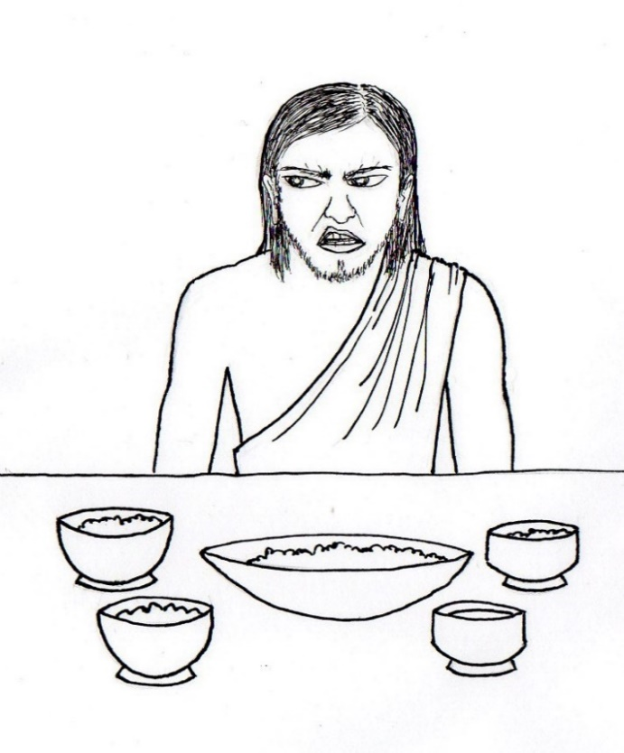

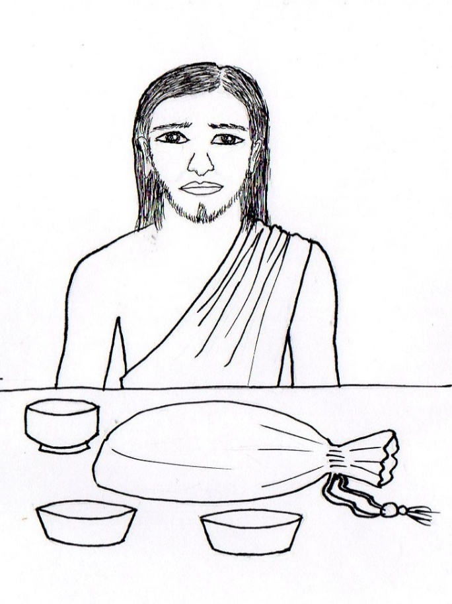

CHAPTER 7 – BRIBED TO HEAR THE DHARMA

Anāthapindika was a wealthy and very generous merchant who often helped the poor and needy. A devoted and famous supporter of the Buddha, he spent all his wealth to buy Prince Jeta’s park and build a monastery for the Buddha and his monks in that park, near the town of Savatthi. It was called Jetavana monastery, and became the most well-known of the Buddha’s monasteries, where the Buddha stayed most often.

Anāthapindika had a son named Kala who was not at all interested in the Buddha or in hearing the Dharma. He had no desire to see the Buddha when he visited Anāthapindika’s house and had no desire to offer any help or service for the Buddha or his monks. Kala would just stay out of sight whenever the Buddha or his monks came to the house.

In addition, whenever Anāthapindika said to him, “Dear son, don’t do this,” Kala paid no attention to what his father said.

Anāthapindika was very worried about his son. He thought, “If this son of mine continues with such an attitude, he will end up in a hell-world. But it wouldn’t look good for me if my son goes to a hell-world right in front of my eyes. There is no living being here in the world who can’t be trained by gifts. I will therefore train him with gifts.”

So, he said to his son, “Dear son, take the Eight Precepts for the full-moon day, go to the monastery, listen to the Dharma, and then return home. If you will do so, I will give you a hundred pieces of money.”

Kala, eager to receive the money but wondering whether his father was being serious, responded, “Will you really give me this, father?”

“I will, dear son,” Anāthapindika replied.

A hundred pieces of money was quite a lot. To make sure he really meant it, Kala asked, ““Will you really give me a hundred pieces of money if I do this?”

Anāthapindika confirmed, “Yes, dear son.”

Kala wanted to make absolutely sure it was a promise, so he asked yet again, “You will really give me the money if I go and do this?”

Anāthapindika confirmed again that he would. It was a promise. Kala then took the Eight Precepts—he vowed for that day that he would refrain from killing any living being, refrain from taking anything that is not given to him, refrain from having any sexual activity, refrain from lying or dishonesty, refrain from intoxicants that cause carelessness, refrain from eating between noontime and sunrise, refrain from entertainment such as participating in dancing, music, or shows, or wearing flowers, make-up, perfume, jewelry or any other decorations, and refrain from using luxurious seats or beds.

He went to the Jetavana monastery where the Buddha was staying. But he wasn’t interested in hearing the Dharma. So, he found a pleasant place to lay down away from other people, and went to sleep. He returned home early in the morning.

As he arrived home, his father said to the servants, “My son has taken the Eight Precepts. Bring him rice-porridge and other food right away.”

With the food placed in front of him, Kala said, “Unless I receive the money, I will not eat.”

Kala stubbornly refused to even touch the food. His father didn’t want to force him to eat, so he ordered a servant to bring a hundred pieces of money and give it to Kala. When the money was brought, Kala took it in his hands and then he ate the food.

The next day, Anāthapindika said to Kala, “Dear son, I will give you a thousand pieces of money if you will stand in front of the Buddha, learn a single verse of the Dharma, and then return to me.”

Kala then went to the monastery and stood in front of the Buddha, who was teaching the Dharma. He memorized one of the verses the Buddha spoke, and then he wanted to leave immediately, having done what his father told him to do. But then he thought about what would happen when he got home—his father would ask him what the verse meant. He didn’t know what it meant, so he said to himself, “I will learn the next verse.” So, he decided to stay longer to hear and then memorize a verse that might be easier for him to understand.

The Buddha knew that Kala was only interested in getting money from his father and wasn’t really interested in learning the Dharma. So, he had caused Kala to feel confused so he wouldn’t understand the meaning of the verse and then stay longer to hear more of the Dharma. People who listen to the Dharma with a firm intention to learn will listen carefully, and if they do, it is possible to reach the first level of enlightenment or even higher levels.

Kala listened to the Dharma with a firm intention to learn. But the Buddha caused Kala to misunderstand the true meaning of the next verse. So, again, Kala thought, “I will learn the next verse,” and he continued listening carefully to the Buddha teaching the Dharma.
Suddenly, Kala deeply understood what the Buddha was teaching and reached the first level of enlightenment. He was full of a great joy, peace and contentment that he had never felt before. No amount of money could have made him feel so happy.

The next day, Kala went with the Buddha and his monks to the town of Savatthi. Anāthapindika saw him with the monks and thought, “Today the attitude of my son pleases me.”

Kala thought, “I hope my father won’t give me the money today in front of the Buddha. I hope he will keep it secret that I took the Eight Precepts for money.” Kala didn’t want the Buddha to know, but of course, the Buddha knew it anyway.

Anāthapindika offered rice porridge to the Buddha and his monks, and also offered rice porridge to his son. Kala sat down silently, drank the porridge, and ate the rice and other food that was offered.

When the Buddha finished his meal, Anāthapindika placed a bag containing a thousand pieces of money in front of his son and said,

“Dear son, remember that I persuaded you to take the Eight Precepts and to go to the monastery by promising to give you a thousand pieces of money. Here are your thousand pieces of money.”

With the thousand pieces of money presented to him in the presence of the Buddha, Kala was extremely embarrassed and said, “I don’t want the money.”

Anāthapindika insisted, “Take the money, dear son.”

But Kala refused to touch it.

Anāthapindika bowed to the Buddha and said, “Lord, today the attitude of my son pleases me.”

The Buddha replied, “How is that, great wealthy one?”

Anāthapindika explained, “The day before yesterday, I sent him to the monastery, saying to him, ‘I will give you a hundred pieces of money.’ Yesterday he refused to eat because I didn’t give him the money, but today, when I give him the money, he refuses to touch it.”
The Buddha said, “It is so, great wealthy one. Today, in attaining the first level of enlightenment, your son has attained that which is better than the attainment of a world emperor, the attainment of the heaven-world of the gods, or the attainment of the heaven-world of brahmas.”

Then he said, “Better than being the only king over the Earth, better than going to heaven, better than lordship over all worlds, is the attainment of the first level of enlightenment.”

Questions:

1. What did Kala do when the Buddha or his monks visited his house? (he stayed out of sight and didn’t offer to help)

2. How did Kala’s father convince him to visit the Buddha at the monastery? (he offered Kala money)

3. What did Kala do when he arrived at the monastery for the first time? (he slept)

4. How did Kala’s father convince him to learn the Dharma? (he offered Kala a thousand pieces of money if he would visit the monastery and learn one verse of the Dharma)

5. What happened when Kala listened carefully to the Dharma? (he deeply understood the Dharma teaching and reached the first level of enlightenment)

6. How did Kala feel when his father gave him the thousand pieces of money in front of the Buddha? (extremely embarrassed)

What the Buddha said:

“Pathavyā eka rajjena, saggassa gamanena vā, sabba lokādhi paccena, sotāpattipahalaṁ varaṁ.”
“Better than having absolute power over the earth, better than going to heaven, better than lordship over all worlds, is the fruit of entering the stream of enlightenment.”

Dhammapada 178 (8:11)

Dharma discussion – Happiness and Faith:

Kala was like many young people today, uninterested in the religious activities of his parents.
He didn’t want to learn the Dharma or receive blessings of the Buddha or his monks.
Like many young people, he may have wanted to make his own decisions, he was stubborn, and he thought he knew what would make him happy.
What did he think would make him happy? Money.

Does money make us happy? In what ways does it help make us happy?
Money enables us to live a comfortable life—have a nice home, good food, get the things we need and the things we like.
Also, many people feel more important and respected when they have more money.
But, are we always fully satisfied and happy if we have a lot of money?
No, we still experience suffering no matter how much money we have.
All the richest people in the world may seem happy, but like everyone else, they cannot stay happy for long.
They want something else, something more, something better, to make them feel happy again.

That is because the human mind that is not yet enlightened cannot stay happy all the time.
Can you think of a time when you felt extremely happy? How long did the happiness last?
Whenever we experience joy, we feel it for a while, but sooner or later we feel some kind of unpleasantness—for example, we feel annoyed, bored, tired, disappointed, frustrated, worried, embarrassed, angry, or jealous.
The thrill of getting what we want, getting something new, or achieving something great wears off—the happiness fades away—and we have to face the problems, difficulties, and uncomfortable situations of our daily lives.
Our pleasant feelings and unpleasant feelings come and go, over and over, every day.
The wealthiest, most successful, most powerful, most attractive, and most famous people might not have to face all of the same difficulties that others must face, but they get used to living the way they are—and then just like everyone else, they feel negative emotions—frustrated, annoyed, jealous, embarrassed, angry and so on—when things don’t go their way, when they don’t get what they want, when they are blamed, rejected, or unsuccessful, and when they face things they don’t like.

This is the way the human mind is.
The Buddha knew this, that the human mind experiences pleasant and unpleasant feelings, satisfaction and dissatisfaction—over and over, every day. The unpleasantness or dissatisfaction, whether just a little or extreme, is called suffering in Buddhism.
Even during the times that we experience the happiest moments, or the thrill of our lifetime, we know it can’t last forever, and although we want to hold onto that feeling, we know we can’t.
So we’re slightly dissatisfied, suffering just a bit, even during those times.

The Buddha found the way to end all suffering—the way to true, lasting, ultimate happiness—and he wanted to share it.
The problem is, most people, like Kala, don’t believe it. Why don’t they believe it?
In the time of the Buddha, there were many holy men who preached ways to find peace and happiness, but none of them resulted in the end of all suffering, which is full enlightenment.
And today, there are countless people, organizations and companies that claim to have some method or product that will make us feel tranquil and happy, but they don’t end our suffering or result in pure, ongoing happiness.
So why should anyone believe that the Buddha is any different?

A few wise people, when they saw the Buddha or one of his advanced monks, could see just from the extremely serene, glowing look on their face that they had found a way to true peace and happiness.
And a few other people saw the Buddha or one of his advanced monks do some miraculous act—such as when the Buddha showed water and fire coming from his body at the same time—which showed he was enlightened.
But most people who saw the Buddha had to listen carefully to his teachings before they believed that the teachings were the way to true happiness.
And many of them, like Kala, reached the first level of enlightenment just by hearing the Buddha teach the Dharma on one occasion.

How was that possible, when Kala had been so disrespectful to his father, refusing to do what his father asked him to do, and when Kala had been totally uninterested in Buddhism?
Ordinary people today don’t reach any level of enlightenment just hearing a bit of the Buddha’s teachings.
There are two main reasons for Kala being able to reach the first stage of enlightenment:
First, a person can only reach a level of enlightenment if they have enough merit (in other words good karma) and enough wisdom built up in many past lives.
Second, being in the presence of the Buddha. The Buddha had such wisdom and power that for many people, just being near him relaxed and opened their minds so they could easily understand the deep meaning of his teaching, even if it was just a few words.
So, Kala must have had enough merit and wisdom gained from past lives to deeply understand the Dharma when he listened to the Buddha teaching.

What about now, around 2600 years later, when we can’t see the Buddha in person, how can we trust that his teachings really will bring us peace and happiness?
The Buddha taught us to test his teachings by applying and practicing them in our daily life, and see for ourselves how they help us.
We can see for ourselves how the teachings make us more peaceful, patient, tolerant, kind, and better able to handle challenges and difficult situations.
Also, maybe we can observe people we know who sincerely practice the Dharma—do they seem more peaceful than ordinary people who don’t do any Dharma practice?
And, there are some Buddhist practices that have now become popular all over the world, because they help people become more peaceful and happy.
Can you guess what those practices are? Mindfulness and meditation.

Have you ever wondered whether there are people living in modern times, or even living now, who have reached the first level of enlightenment, or even higher levels?
There are such people, but usually they don’t let others know about it, because they don’t want to attract crowds of curious people who aren’t really interested in practicing the Dharma.

Chapter 8 pictures

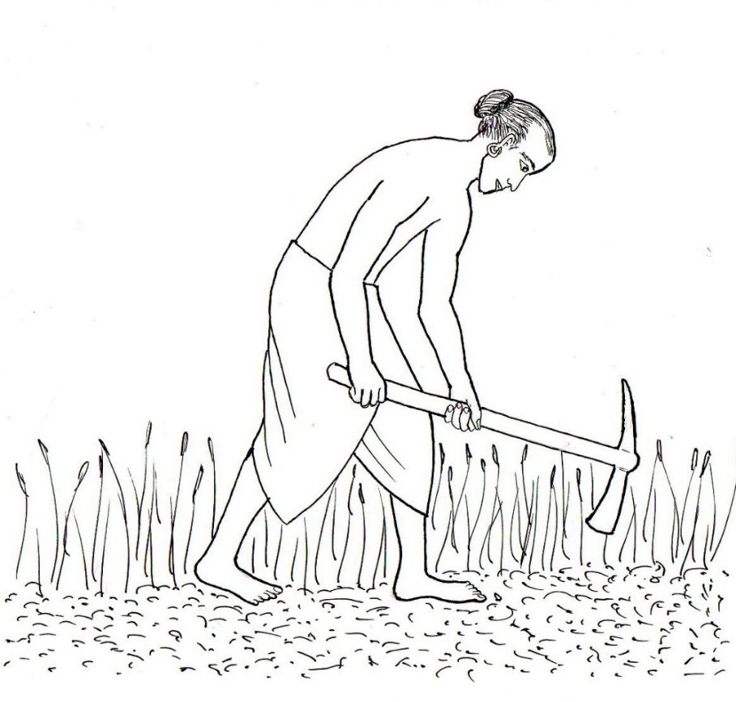

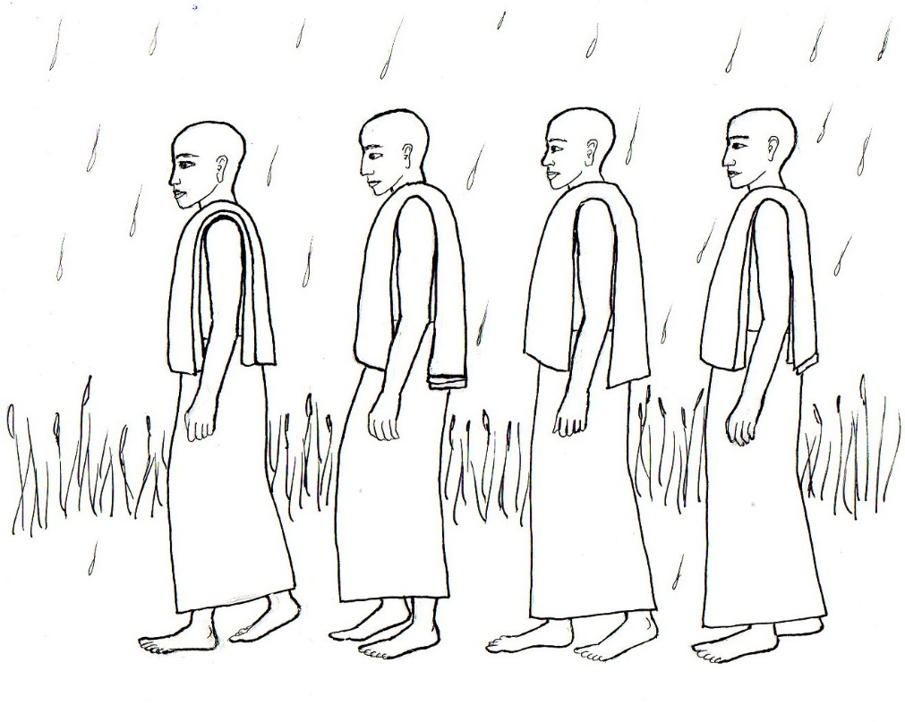

CHAPTER 8 – LITTLE BY LITTLE

There was once a brahmin who often visited the Buddha and his monks near the city in which he lived. A brahmin is a person of the most respected or upper class of society in India, and brahmin men traditionally were priests, spiritual teachers, intellectuals, scholars, or advisors to a king.

Early one morning, the brahmin took a walk and went to a place where the monks usually stopped on their way from the place they were living to put on their upper robe before walking into the city. In the hottest weather when they were alone or only among other monks, they would wear just their lower robe with their upper robe folded over their shoulder. They would stop at this place to drape their upper robe to cover both shoulders. The brahmin liked to meet them there and walk with them into the city where they would receive their daily food from the residents.

When he arrived at the stopping place, the monks already were there, draping their upper robes over their shoulders. As the brahmin stood there, he noticed that this place was thickly overgrown with long grass. And he noticed that as one of the monks put on his robe, the edge of the robe dragged through the grass and became wet from the drops of dew which clung to the blades of grass in the early morning.

The brahmin considered that the wet robe would look untidy and feel uncomfortable. He felt that something should be done to prevent the monks’ robes from getting wet in the long, wet grass. He thought, “The grass should be cleared away from this place.”

So, on the following day, he brought his pickaxe to that place and cleared all the grass away. He then flattened the ground to make it as smooth and flat as a floor.
The next day, he went back to the stopping place. As the monks put on their upper robes, he noticed that the edge of the robe of one of the monks dropped to the ground and dragged in the dust.

The brahmin observed that the robe looked dusty and dirty. He felt that something should be done to prevent the monks’ robes from getting dirty when touching the bare ground. He thought, “Sand should be sprinkled here.”

So, he loaded a cart with sand, brought it to the monks’ stopping place and spread the sand carefully and evenly over the bare ground.

Some days later, the heat was intense. When he went to meet the monks at their stopping place, he noticed that as the monks were putting on their robes, sweat was pouring from their bodies. The brahmin noticed that in the sun, the heat was almost unbearable, but in the shade, it was cooler. He felt that if all the monks had a place in the shade to stop and put on their upper robes, they would have protection from the hot sun and be more comfortable. He thought, “Here I ought to have a shelter built.”

So, he bought wood and other building materials and organized some people to build a shelter at the stopping place. He was very pleased when he offered the shelter to the monks.

Another day, early in the morning, it was raining. As the brahmin watched the monks arriving at the stopping place, he noticed that their robes had gotten wet while walking in the rain. He considered that they wouldn’t need to walk in the rain all the way back to the place they were living if a hall were built there. Then they could stay in the hall to eat, meditate and teach the Dharma. He thought, “Here I ought to have a hall built.”

So, he bought a lot of wood and building materials and organized some people to build a large hall. When the hall was completed, he thought, “Now I will hold a festival in honor of the completion of the hall.”
He invited the Buddha and his monks, the Sangha, to come to a festival at the hall. He along with others prepared food for all of them. When the Buddha and his large group of monks arrived, he guided them to their seats. There were so many monks that some were seated inside the hall and some were seated outside the hall. Then he and other volunteers offered the food to them. The brahmin felt very happy about the offerings he had made.

At the end of the meal, he took the Buddha’s bowl as a signal to the Buddha to speak some words of appreciation for the meal.

The brahmin said to the Buddha, “Lord, as I stood in the place where the monks were putting on their robes and watched them, I saw that a monk’s robe became damp from the wet grass, so I cleared away the grass and smoothed the soil for the monks. Then later I saw that a monk’s robe dragged in the dust on the bare ground, so I sprinkled sand over the ground. Then on a very hot day, I saw that the monks were sweating, so I had a shelter built for them and then they would be protected from the hot sun. On another day, I saw the monks’ robes getting wet from walking in the rain, so I had a hall built and then the monks wouldn’t have to walk in the rain so much.”

The Buddha listened to him and then said, “Brahmin, a wise man by doing good works, time after time, little by little, gradually removes the stains of his own unwholesome deeds.”

The Buddha then explained with this stanza: “By gradual practice, little by little, from time to time, a wise person should remove his own impurities, as a smith removes the impurities from silver.”

Questions:

1. What are men in India called who traditionally were priests, spiritual teachers, intellectuals, scholars, or advisors to a king? (brahmins).

2. What did the brahmin notice one the first morning in the story when he went to the monks’ stopping place? (that a monk’s robe got wet from the wet, long grass)

3. What did the brahmin think he should do when he saw the monk’s robe had gotten wet from the grass? (remove the grass from the stopping place)

4. What else did the brahmin do to help the monks? (spread sand over the ground, had a shelter built, had a hall built, and offered food to the monks)

5. How did the brahmin feel after he had made the offerings to the monks? (very happy)

6. According to the Buddha, when we do good works, good deeds time after time, little by little, what do we gradually remove? (our impurities)

What the Buddha Said:

“Anupubbena medhāvi thoka thokaṁ khaṇe khaṇe, kammāro rajatass’ eva niddhame malam attano.”
“By gradual practice, little by little, from time to time, a wise person should remove his own impurities, as a smith removes the impurities from silver.”

Dhammapada 239 (18:5)

Dharma discussion – Awareness and Service:

The brahmin seemed like a servant to the monks, looking out for their comfort and even for their minor needs like keeping their robes dry and clean.
But, a brahmin is an upper class, educated, well-respected person—one who would not behave like a servant, so why would the brahmin behave like a servant to the monks?
Because he felt that it was a great honor, a great opportunity, and great good fortune to be able to serve the monks.
The Buddha’s monks were much more worthy of respect than he was, because they are deeply immersed in learning and practicing the Dharma to reach enlightenment, the highest goal.
Kings may have a noble purpose to govern many people, but that is not the highest goal in life.
And kings may be worthy of great respect from most people, but kings and brahmins bow to the Buddha and his monks and consider them to be more worthy of respect because of the monks’ greater wisdom and purity.
So, brahmins, wealthy people, and even kings were willing to serve and be very generous with their time, energy, food, and wealth to support and help the Buddha and his Sangha.
Why did they have such motivation to do this?
One reason is that it creates merit—good karma—ensuring their good future.
Another is that it made them feel happy knowing they were supporting the monks to teach more people the Dharma, attract more people to become monks and encourage more people to practice the Dharma, making the world more happy and peaceful.
And yet another reason is that it helped them develop good qualities and get rid of impurities.

Can you think of good qualities that we develop when we help others, such as monks, our parents and teachers?
When we give something, such as our time and energy, what is the feeling that we give with, or what is the good quality do we develop? Generosity.
What feeling or good quality might you have in your heart when you see someone who is stressed, uncomfortable, struggling, upset, in pain, or needing help? Compassion.
What feeling or good quality should you have in your heart toward those you are helping? Lovingkindness.
What quality, the opposite of arrogance, do we develop when we serve others? Humility.

What did the Buddha mean when he said that by doing good works, time after time, little by little, we gradually remove our impurities?
He meant that by doing good deeds, helping others, again and again, we get rid of our impurities, or negative qualities, such as ignorance, hatred, greed, jealousy, and arrogance.
We can see for ourselves how this happens because any unpleasant feelings that we might have tend to decrease or disappear during the time we are helping someone.
Even if we didn’t feel like helping at first, what happens to our bad mood, boredom or anger, once we are very busy helping someone? We tend to forget it, so it goes away.
And what happens to our laziness and selfishness? They disappear.
When we help others, we focus on them—what they need, what they would like—so we forget our own unpleasant feelings and our self-centeredness.
And we can enjoy the feeling of others being pleased with our help.

How can we find ways to help others?
We can learn from the brahmin in the story, how he started helping the monks.
What brought his attention to the need to remove the grass, to put sand on the ground, and to build the shelter and the hall?
He was noticing something. What did he notice? That the monks might be uncomfortable or might look untidy.
If he wasn’t noticing—carefully observing—whether others might be uncomfortable, need something, or want something, then he wouldn’t have had the ideas of how to help.
So, noticing—being aware—of whether others are uncomfortable, or might need or want something, gives us hints of how we can help.

How can we become more aware—how can we develop our awareness?
First, notice what gets in the way of our awareness—what habits make us unaware, distracted.
Many of us have a habit of looking at our screens too much—our phone, tablet, TV, videogames.
And some of us have a habit of only focusing on our friends and ignoring whatever else is going on around us.
Second, we can practice mindfulness.
Mindfulness makes us more and more aware of what Is going on around us.

The brahmin in the story also shows us another method of finding ways to help others.
He started with something very simple—clearing away grass.
We too can start with helping our parents in simple ways. Can you think of any?
Carrying groceries, putting them away, setting the table before eating, clearing the table after eating, wiping the table, washing dishes, putting away clean laundry and dishes, sweeping the floor. What other activities can you do to help at home?
When we notice more ways to help more at home, then we develop a habit of helpfulness—and then we notice more and more ways to help wherever we are.
The brahmin started with the simple, perhaps boring service of clearing away grass and then he noticed more ways to help, and ended up with a very noble service of building a hall for the monks and organizing a festival for them, which he enjoyed.
Similarly, when we start helping in simple ways, like helping our parents, we develop a habit of helpfulness, and then we find all kinds of opportunities to be helpful.
Then we can find more interesting ways to volunteer, doing activities we enjoy very much.

Chapter 9 pictures

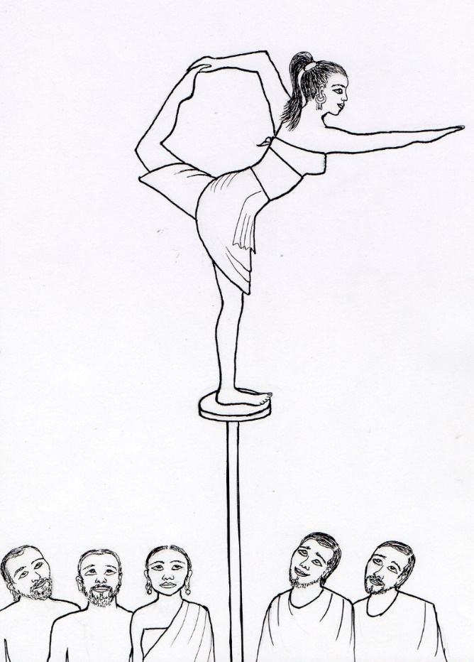

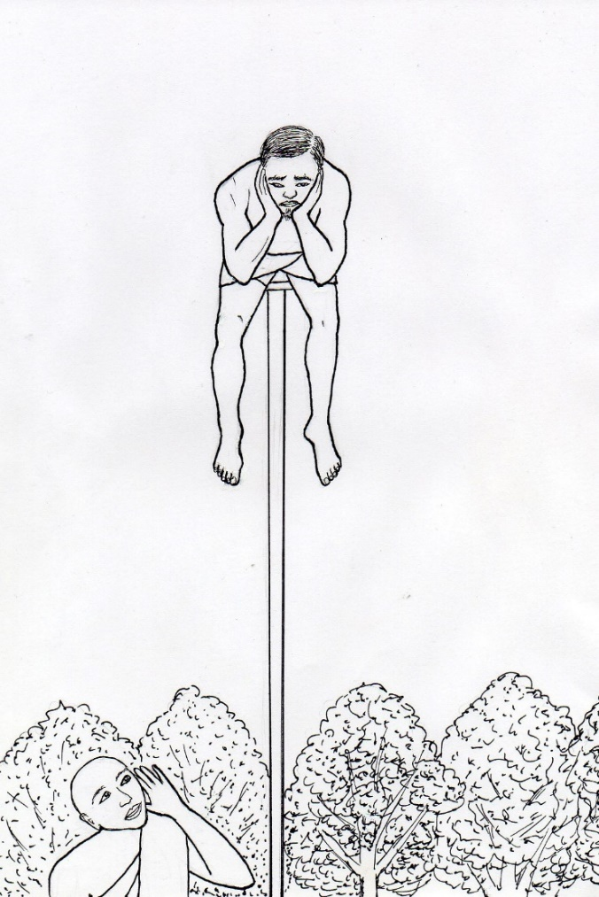

CHAPTER 9 – THE ACROBATS

Every year, or sometimes twice a year, a large group of acrobats traveled to the city of Rajagaha in India to perform for the king for seven days. They earned a lot of gold and money for their performances. People were so amazed by the acrobats’ skill that they tossed gifts and money on the acrobats’ stage during the whole week. And everyone in the town wanted to see the wonderful performances. They piled up beds one on top of another so they could sit or stand on the beds to see over the big crowd.

One day, an acrobat who was a young woman climbed up a pole, made somersaults on the pole, and then, balancing herself on the tip of the pole, she danced and sang beautifully.

In the audience, standing on top of a pile of beds were two young men who were friends. One, named Uggasena, was the son of a very wealthy merchant. He watched the acrobat dancing and was mesmerized by her skill in moving her hands and feet. He admired the graceful way she danced. He adored her beauty and was totally fascinated by her. He immediately fell in love with her.

After the performance, he went home and told his parents about her. He was so attracted to her and was determined to marry her, but he was sure his parents wouldn’t approve of him marrying a girl who was the daughter of an acrobat. Therefore, he said,

“If I can have her, I shall live, but if I cannot have her, I shall die right here.”

He flung himself down on his bed and refused to eat when the meal was served.

His father asked him, “Son, what is wrong with you?”

Uggasena replied, “If I can have that acrobat’s daughter, I shall live, but if I cannot have her, I shall die right here.”
His father said, “Son, don’t act this way,” and his mother said. “We will bring you another young lady, who is our equal in society and wealth.”

Uggasena, still lying in his bed, repeated, “If I can have that acrobat’s daughter, I shall live, but if I cannot have her, I shall die right here.”

His father argued with him for a long time, trying to persuade him that he should wait, that a traveling acrobat is not a proper wife for him, and that there are beautiful young ladies from more respectable families whom he could marry. But he couldn’t make his son see the attraction to the young acrobat from a wise perspective. Uggasena could not be convinced to let go of his obsession with her.

Finally, the father sent someone to bring Uggasena’s friend to the house. When the friend arrived, Uggasena’s father gave him a thousand pieces of money, saying,

“Tell the acrobat to take this money and give his daughter to my son.”

Uggasena’s friend went to the acrobat and asked him to accept the bag of money in exchange for permission for his daughter to be married to Uggasena.

The acrobat replied, “I will not give my daughter for money. But, if it is true that he cannot live without my daughter, then let him travel around with us. If he will do this, I will give him my daughter.”

The friend went back to Uggasena’s house and reported to the parents what the acrobat had said. The parents then went to Uggasena and communicated the information to their son.

Uggasena immediately said, “Of course I will travel around with them.”

His parents were shocked and terribly upset that he wanted to leave them and give up the comfortable lifestyle they worked so hard to provide for him, to travel around with people of lower status. They begged him not to do so, but he paid no attention to anything they said. He left the house and went to join the acrobats.

He stayed with the acrobats and helped them with whatever was needed, so the father of the beautiful lady acrobat gave his daughter to Uggasena in marriage. They traveled around through villages, towns with large markets, and royal cities where kings lived, and gave performances everywhere. Uggasena and his wife soon had a baby.

When the wife played with their baby son and sang to him, she called him “son of a cart-driver” or “son of a fetcher of wood and bringer of water” or “son of a know-nothing.” Uggasena indeed took care of everything relating to the acrobats’ carts, such as driving the carts and bringing grass and water for the oxen that pulled the carts, and he carried boxes and set up and took down all the equipment needed by the acrobats for their performances. His wife was referring to his duties when she sang these names to their son. Uggasena knew it, and felt insulted and hurt.

As she sang, he asked his wife, “Are you referring to me?”

She replied, “Yes, I refer to you.”

He said, “In that case I will run away and leave you.”

She responded coldly, “What difference does it make to me whether you go away or not?”

She continued singing the same songs, over and over. Apparently, she felt that she didn’t need him because of her beauty and skill and the large amount of money she earned from her acrobatic performances, so she didn’t care about him.

He thought, “Why is she so arrogant?” And then he considered, “It’s because of her skill as an acrobat.” So, he thought to himself, “Very well! I will learn to be an acrobat myself.”

So, he went to his wife’s father and after a while he learned all the acrobatic routines that his father-in-law knew. When they traveled to villages, market-towns and royal cities, Uggasena performed along with the other acrobats.

One day, they were on the way to perform in Rajagaha, Uggasena’s home town. He told the town messengers to announce, “Seven days from today Uggasena the wealthy merchant’s son will exhibit his skill to the residents of the city.”

The residents of Rajagaha built platforms and stacked them one upon another within seven days. On the day of the performance, Uggasena climbed an extremely long pole and balanced himself on top of it.

Earlier that day, as the sun was beginning to rise, the Buddha looked at the world with his mind—his inner eye—and saw Uggasena. The Buddha considered, “What will become of him?” Immediately he became aware of what would happen that day. He saw that Uggasena, the wealthy merchant’s son, will balance himself on the tip of a pole for the purpose of displaying his skill, and a huge crowd will be there to see his performance. And he, the Buddha, will speak a stanza of four lines of the Dharma. Hearing this stanza, 84,000 living beings will understand the Dharma and Uggasena himself will become an arahant. The Buddha knew that Uggasena was now ready to realize the Dharma.

So the Buddha, along with many of his monks, walked into the city of Rajagaha to receive their food for the day.

A moment before the Buddha entered the city, Uggasena motioned to the audience as a signal for applause. Balancing himself on the top of the pole, he turned somersaults in the air, and landed on his feet, again balancing himself on the top of the pole.

At that moment, the Buddha entered the city and made an intention that the crowd should look at him rather than at Uggasena. When Uggasena looked at the audience and saw that they all were not looking at him, he was overwhelmed with disappointment. He thought, “Here is a stunt which has taken me a year to perfect, but when the Buddha enters the city, the audience, instead of looking at me, looks at the Buddha. My performance has failed completely.” He just sat on the pole, in deep despair, feeling completely worthless.

The Buddha, knowing the thought that was in Uggasena’s mind, said to the Venerable Mogallana, “Go and inform the wealthy merchant’s son that the Buddha wants him to show his skill.”

Venerable Moggallana went and stood at the base of the pole, and said to Uggasena, “Please look, Uggasena, acrobat of mighty strength. Perform for the crowd; make the people smile.”

When Uggasena heard the words of this great monk, he was delighted, thinking, “No doubt the Buddha wants to see my skill.”

As he balanced himself on the top of the pole, he said, “Please look, Moggallana, mighty in wisdom and power. I perform for the crowd; I make the people smile.”

Then he sprang into the air from the top of the pole, turned twice as many somersaults as he had done before, and landed on his feet, balancing himself again at the top of the pole.

The Buddha said, “Uggasena, a man that is wise should let go attachment to the things of the past, the present and the future; then he should win release from birth, decay, disease, and death.” Then the Buddha said the following stanza:

Let go what is past,
Let go the future and the present;
With a mind freed from all things of the world
You will not again come to birth and decay.

This means to let go of, not be attached to, what was in the past, what is in the present, and what is in the future. When we release attachments—when we let go of what we are attached to—then we become enlightened and don’t have to suffer in future lives.

At the end of this lesson, 84,000 living beings understood the Dharma. Uggasena, even as he stood on the top of the pole, became an arahant and attained higher powers.

He immediately came down from the pole, walked up to the Buddha, bowed to him, and respectfully requested the Buddha to permit him to become a monk.

The Buddha stretched out his right hand and said, “Come, monk!”

At that moment, the eight items required by a monk appeared—upper, lower and outer robes, a bowl, a razor, a needle for mending, a belt and a water filter. Suddenly, Uggasena looked like an old monk.

The monks, curious about his life as an acrobat, asked him, “Friend Uggasena, didn’t you have any fear as you came down from that long pole?”

Uggasena replied, “Friends, I have no fear.”

The monks went to the Buddha and said, “Lord, Uggasena says ‘I have no fear’; he says that which is not true—he’s telling a lie.”

The Buddha replied, “Monks, those monks who, like my son Uggasena, have given up the attachments, have no fear or worry.” Then he said the following verse:

“He who having cut all that binds him trembles not,
Gone beyond ties, free from bonds—that one I call a brahmin.”

The monks wondered how someone could be an arahant—so advanced in wisdom—when he had just become a monk after having traveled around as an acrobat so he could have a pretty acrobat for a wife. They began a discussion about it. One of them said,

“Friends, how did it happen that a monk, who had what was necessary to become an arahant as this monk had, traveled around with acrobats for the sake of an acrobat’s daughter? And how did it happen that he had what was necessary to become an arahant?”

The Buddha came up to them and asked, “Monks, what is the subject you are discussing as you sit here all gathered together?”
When they told him, he said, “Monks, both of these things happened through one and the same circumstance.”

Then he told them the following story of the past:

A long time ago, a young couple loaded their cart with a lot of food to serve to workers who were building a golden shrine for the relics of the buddha of the past, named Buddha Kassapa. Along the way as they were traveling to give the food to the laborers, they saw a monk entering the city to receive food. The young woman looked at the monk and said to her husband,

“The noble monk is entering the city for food and there is so much food in our cart. Fetch his bowl and let’s give him food.”

The husband went to the monk and brought his bowl, and then they filled it with food and placed it in the hands of the monk. As they did so, they both made the wish, “Lord, may we be able to realize the Truth that you have seen.”

The monk was an arahant, so he could look into the future to see whether their wish would be fulfilled. He saw that it would be fulfilled, and he smiled. The couple didn’t know he was an arahant or why he was smiling, so they assumed he was just pretending to know something. The wife said to her husband, “The noble monk smiled; he must be some actor.”

The husband agreed, “He must be indeed, my dear wife.”

After the couple passed away, they were reborn as gods in a heaven-world, and later the wife was born as the acrobat’s daughter and the husband was born into the wealthy merchant’s family as Uggasena. Because in that former life he had agreed with his wife that the monk smiled because he was just acting, he had to travel around with actors—acrobats. But because he gave food to an arahant, that good deed became a cause for him to become an arahant.

Meanwhile, the acrobat’s daughter, her husband now having become a monk, wished to herself, “whatever future state my husband shall attain, that I will also attain.” This led to her becoming ordained as a nun into the Buddha’s Sangha, and later she became an arahant, too.

Questions:

1. What did Uggasena do when he arrived home, to show his parents how much he wanted to marry the acrobat? (he threw himself on his bed, refused to eat, and said he would die if he can’t have her)

2. How did Uggasena’s parents feel when Uggasena agreed to travel with the acrobats to marry the acrobat’s daughter? (they were shocked and terribly upset)

3. How did Uggasena feel when his wife sang songs to their baby, calling him a “son of a cart-driver” and “son of a know-nothing”? (insulted and hurt)

4. Who did the crowd look at when Uggasena somersaulted at the top of the pole and the Buddha entered the city? (the Buddha)

5. How did Uggasena feel when the crowd looked at the Buddha and ignored him? (overwhelmed with disappointment, in deep despair, completely worthless)

6. Where was Uggasena when the Buddha taught him to let go of attachments and then Uggasena became an arahant? (at the top of the pole)

What the Buddha said:

“Muñca pure muñca pacchato, majjhe muñca bhavassa pāragū, sabbattha vimutta mānaso, na puna jātijaraṁ upehisi.”

“Let go the past, let go the future, let go the present. Having reached the end of existences, with a mind freed from all (conditioned things), you will not again undergo birth and decay.”

Dhammapada 348 (24:15)

Dharma discussion – Attachment and Impermanence:

What does “attachment” mean? Our feeling toward whatever it is that we like or want to keep.
It’s our clinging to, our wanting to have, or our desire to keep, whatever it is that we like.
We can be attached to certain friends, pets, toys, sports, videogames, favorite activities, favorite places, favorite foods, smartphones, social media, and many other things.
What are you most attached to? We all have many, many things we are attached to.
We’re strongly attached to some things and not so strongly attached to other things.
Sometimes we can be too attached to something.

Uggasena was too attached to the lady acrobat.
When we are too attached, what problems can arise?
As we see from Uggasena, we can become so focused on what we’re attached to that we forget about important things such as our family and our responsibilities.
He was so obsessed with the lady acrobat, even without knowing anything about her, that he forgot about everything he had—his family, friends, community, lifestyle, education and wealth. Have you ever forgotten something important because of a favorite thing you’re strongly attached to? For example, have you ever forgotten to do something important because you were so attached to a game you were playing?

Uggasena was extremely attached to something else, once he learned to be an acrobat.
Can you guess what it was? His acrobatic skill and the admiration from audiences.
How do we know he was so strongly attached? Because when he didn’t get the admiration—when he was ignored—he went into deep depression, despair, and felt worthless.
So, another problem that can arise when we’re too attached to something is that we get terribly upset if we can’t have it or when we don’t have it anymore.
For example, if we aren’t allowed to have it or if someone takes it away, we become depressed, disrespectful, aggressive, angry, or even violent, throwing things or hitting someone.

Even if we have what we are attached to, does it give us joy?
It does for a while but doesn’t give us fully satisfying, lasting happiness.
Why is that? Because everything changes.
Things change: things become old, broken, damaged, lost or stolen; things come and go.
People change: their interests change, or they disappoint us, move away, or find other friends.
Circumstances change: sometimes we’re successful and sometimes unsuccessful, sometimes we win and sometimes we lose, sometimes we’re admired and sometimes we’re criticized or ignored; something better becomes available; what is popular becomes unpopular.
And we change: our interests change, our feelings change, and we often want something new.
What gave us great joy later on can give us no joy at all, or even the deepest disappointment.

Everything changes and is impermanent; it doesn’t last forever.
When we know this, then we can avoid being like Uggasena, getting so attached to one friend or one thing that we neglect other people and other important things.
And, if we remember that everything changes, we can begin to calm our feelings of anger or depression when we can’t have what we want.
Also, remember that we learn from our losses, failures, criticisms and disappointments; we learn how to do better next time, and we learn how to learn how to cope with changes.

That is how we can begin to let go of extreme attachment.
The Buddha taught about letting go of attachment to things of the past, present and future.
What things of the past, present and future are we attached to?
The past is our memories. When we’re too attached to things of the past—our memories, thinking about what has already happened—then we might feel sad, upset or distracted from what is going on now, and then we miss opportunities that we have right now.
The present is right now. If we’re too attached to things in the present, then we want to keep on enjoying what we are enjoying right now. And we get upset or angry when it changes.
Attachment to the future means our hopes and expectations. If we are too attached to our hopes and expectations, then we get very disappointed or angry when things don’t go our way.

When we remember not to be too attached, that everything changes and is impermanent, then we can reduce all those unpleasant feelings.
In the story, the Buddha also taught the monks that people who have let go of their attachments have no fear or worry.
Let’s see how this can apply to us.
If you are trying to win a competition, how would you feel when others start winning?
You might worry or fear that you are going to lose.
That can be a good way to motivate yourself to perform better, to try harder to win.
But if we are too attached to our hope or expectation of winning, then we might have so much worry or fear that we lose concentration and perform worse, or we might get terribly upset and become a “poor sport” if we don’t win.
If you are trying to make a new friend, how would you feel if that person ignores you?
You might worry of fear that they don’t like you.
If you are too attached to having that person as your friend, you might start acting bossy, overly controlling, depressed or jealous, which could make the person less likely to be your friend.

It’s more important for our well-being and overall happiness to learn not to be too attached than to always get what we want.

We can love other beings, we can enjoy things, competitions and other activities, we can experience and have fun, and plan and hope for the future.
But we remember that everything changes, nothing lasts forever, so we enjoy it while it lasts, and we don’t expect it to be permanent and give us constant, unending joy.
And we aren’t so upset and hurt when they do change.

Chapter 10 picture

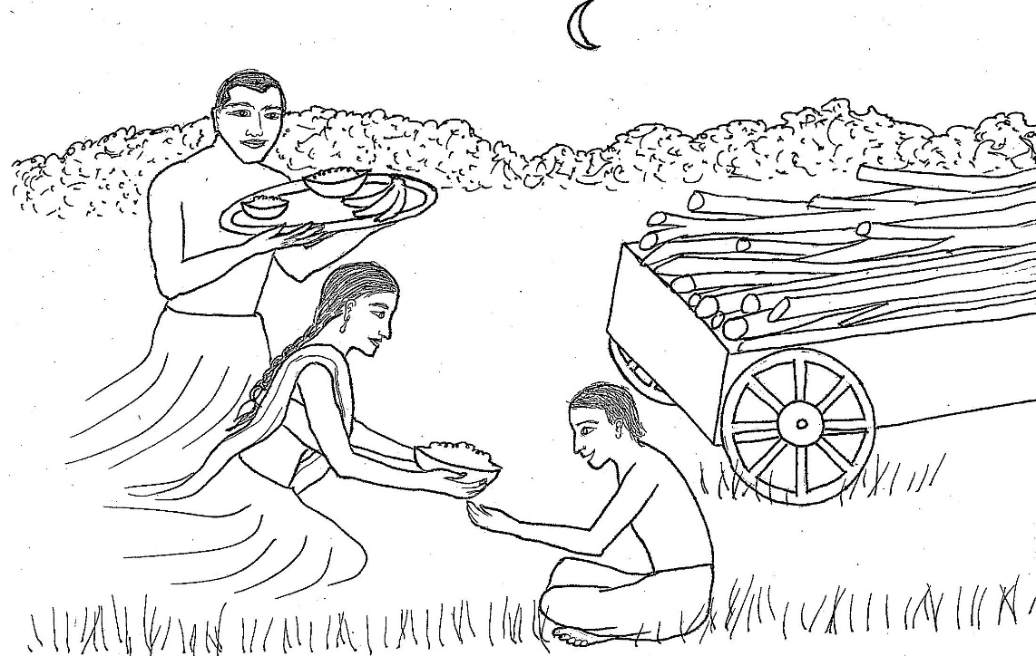

CHAPTER 10 – THE BOY AND THE SPIRITS

There was once a woodcutter who traveled into a forest with his son in a cart pulled by oxen to cut some firewood. On their return home in the evening, they stopped near a cemetery to have their dinner. The woodcutter took the yoke off of the two oxen to let them walk around so they could eat, too.

As they were grazing on the fresh grass, the oxen wandered away. The woodcutter and his son were enjoying their dinner and didn’t notice that the oxen had wandered away. When he finally noticed that the oxen were gone, the woodcutter quickly went out alone to look for them, and left his son with the cart to guard the firewood so it wouldn’t be stolen. The woodcutter looked around for a while but he couldn’t find the oxen. He suspected they might have gone back home, in the city. So, he went into the city and there he found the oxen. He led them back toward the city gate to go back to his son and the cart.

But as he approached the gate, he saw that it was closed for the night! There was no way to leave the city, which was surrounded by stone walls. He had to leave his son and the cart alone for the night near the cemetery. The woodcutter slowly led the oxen back home, hoping his son would be okay staying alone during the night.

Meanwhile, as the sun set and it became dark, the boy realized that his father would not be returning that night. He knew he would have to spend the night alone. He crawled under the cart for protection from any rain and tried to fall asleep on the grassy ground.

Just as he was dozing off to sleep, he felt a tug at his leg. He realized it wasn’t a dream, and it wasn’t his imagination. Something—or someone—or some creature—was pulling at his leg. Was it an animal? A robber? A ghost?

He immediately cried out, “Namo Buddhassa!” which means, “Honor to the Buddha!”

Indeed, the boy’s family were devoted to the Buddha, and every day the boy regularly contemplated the unique, wonderful qualities of the Buddha, such as his great compassion, lovingkindness and power. The boy knew that if he thought about the Buddha, or called out to him, the Buddha would protect him.

The beings who pulled his leg were spirits—beings who were in another dimension. But they could interact with people if they wanted to. They had pulled the boy’s leg to try to frighten him.

But, hearing the boy call out to the Buddha, the spirits themselves were frightened! They knew that the Buddha was extremely powerful, and that he wouldn’t appreciate them frightening one of his devotees. So, the spirits felt that they should take care of the boy rather than try to frighten him. What could they do to take care of him? Feed him, of course! And, feed him with the very best food—the food prepared for the king!
One of the spirits rushed to King Bimbisara’s palace and brought the royal tray heaped with food that had been prepared for the king. The other spirit remained near the boy, guarding him from all danger.

The boy didn’t see the spirits, didn’t know what had tugged at his leg and had no idea that spirits visited him or what they were doing. But suddenly, he saw his parents right there with him!

Actually, what he thought were his parents were the two spirits who appeared in the forms of the boy’s parents. They fed him the food from the tray as if he was their own son.

The boy happily ate all the delicious food they offered him.

Then, when his belly was full, he felt very tired after the long day cutting wood with his father. He soon fell asleep, feeling content, without any fear.

The spirits knew the king would be upset that his royal food tray was gone, and would send his men out to search for it. If they found that the boy had it, they would accuse the boy of having stolen it, and the spirits didn’t want to get him into trouble. So, at the palace, the spirit had written a message concerning the tray, and this message would be visible only to the king.

In the morning, the king’s men discovered that the royal food tray was missing. They were very upset and searched all around the palace for it. The king found the message left by the spirit and directed his men where to look for the tray. The king’s men went out to where the cart was and found the royal food tray among the firewood in the cart. They also found the boy, still sleeping underneath the cart. The men brought him to King Bimbisara, along with the tray.

The king asked the boy, “How did this tray appear in your cart?”

The boy answered, “Your majesty, I was alone guarding the cart of firewood for my father while he went to find our oxen that had wandered away while we ate dinner. During the night my parents came to give me food, and they brought it on this tray.”
The king asked, “You were alone when my men found you. Why would your parents bring you food and then leave you alone?”

The boy replied, “After I ate, I felt content and went to sleep without any fear. I know only that much and nothing more, your majesty.”

The king ordered his men to bring the parents of the boy to the palace. The king asked them,

“What happened last night?”

The father explained that he had found his lost oxen in the city but couldn’t leave the city to bring his son and the cart back home because the city gate had been closed for the night. So, he and his wife stayed home all night.

The king asked the boy. “Did anything unusual happen last night before you saw your parents?”

The boy said that before his parents came, he had felt something tugging his leg, and he had called out, “Namo Buddhassa.”

The king asked the parents about the boy’s knowledge of the Buddha. The parents told him that their son was always mindful of the unique qualities of the Buddha.

From these statements of the boy and his parents, and from the mysterious message left at the palace about the tray, the king knew something unusual had happened. The boy had been near a cemetery, and when he felt a tug on his leg and he called out to the Buddha, he was in no danger and was treated very well. Perhaps some spirits had been involved. Only the Buddha would know the truth.

So, he took the boy and his parents to see the Buddha.

The king asked the Buddha, “Is mindfulness of the unique qualities of the Buddha the only method that gives protection against evil and danger, or is mindfulness of the unique qualities of the Dharma equally potent and powerful?”

The Buddha replied, “O king, my student! Mindfulness of the Buddha is not the only protection against evil and danger. Mindfulness in any of the six senses is also a good protection against evil and danger.”

So, the Buddha taught that being mindful of what one sees, hears, feels, smells, tastes or thinks helps protect us against anything evil of dangerous. Also, thinking of the Buddha gives us protection.

The Buddha gave a talk on the Dharma, after which the boy and his parents attained the first level of enlightenment.

Questions:

1. Why was the father unable to get back to his son in the evening? (the city gates were closed)

2. What happened that made the boy scared as he was falling asleep? (he felt something tugging his leg)

3. What did the boy immediately think of when he felt scared? (the Buddha)

4. What did the spirits want to do when the boy called out to the Buddha? (they wanted to take care of him and bring him food)

5. Did the boy know that spirits had visited him? (no)

6. What did the spirit do to make sure the boy didn’t get accused of stealing the king’s tray? (it left a message that only the king could see)

What the Buddha said:

“Suppabuddhaṁ pabujjhanti sadā Gautama sāvakā,
yesam divā ca ratto ca, bhāvanāya rato mano.”
“Fully alert and ever vigilant are the students of Gautama, who by day and night delight in meditation.”
Dhammapada 301 (21:12)

Dharma discussion – Fear and Mindfulness:

Imagine how you would feel if you were all alone and had to sleep outside at night, and suddenly you felt something tugging your leg. You might feel terrified!
The boy in the story might have felt terrified, too.
But, he knew what to do. What did he do?
He called out to the Buddha.
Why did he think of the Buddha immediately when he was in danger?
Because he often thought of the Buddha. It was his habit to think about the Buddha.
So, when he was in shock and needed help, his first thought was of the Buddha.

Have you ever been terribly frightened? Did you call out for help?
If your mother or father was nearby, maybe you called out to them.
But what if you were alone, whom would you call out to for help?
Would you think of the Buddha for protection?

As we learn in the story, thinking of the Buddha protects us.
But, if the Buddha is no longer living on the Earth, can we still be protected by thinking of him?
Yes! We don’t need the Buddha’s body to come and help us.
As he taught, we only need to be mindful of him, to think of him when we’re in danger or frightened.
Then our mind connects with the power of the Buddha, and it protects us.

The Buddha also said that other types of mindfulness will protect us, too.
What exactly does mindfulness mean?
It means we are fully aware of this moment, right now.
We keep our mind in the present moment—right here, right now, not in the past or future.
In each moment, one moment right after the other, we are fully aware—of seeing, hearing, tasting, smelling, or feeling.
We are aware, moment by moment, of each sensation that we receive through our five senses: our eyes, ears, nose, tongue or skin.
We aren’t thinking about something else—remembering something that happened, or planning or expecting something in the future, or wondering about something, or analyzing something.

To practice mindfulness, it’s easier to close our eyes, because our eyes take in so much information that we easily can get lost in thoughts about the things we see.
And it’s easier to sit very still, alone in a quiet place so we aren’t distracted by our body moving around, or the activities of others, or any loud sounds.
While we are sitting still with eyes closed, we notice any sounds that we hear.
We notice the sensations on our skin—such as our clothes against our body, the cool wind, the warm sun, our toes touching each other, our fingers touching each other, our eyelids on our eyes, our tongue against our teeth, the seat or floor under our legs.
We can practice this for a few seconds or a few minutes any time we are anxious, worried, unhappy, or bored, so we feel better and more relaxed.

How does this mindfulness protect us?
We become more alert and aware of our surroundings, so we sense any danger before it gets close, and then we can get away or avoid it.
And, our mind becomes calm so we can think more clearly and find solutions to problems, and so we don’t react in a way we might regret later.
Also, mindfulness takes our mind away from our scary thoughts, so it helps reduce our fear; it helps us not become so fearful that we panic.
It takes our mind away from our fear that our pain or bad experience will keep on hurting us and won’t go away.

When we are mindful, then our mind is full of calm thoughts, so there is no room for worries, fears, and unpleasant thoughts. Then we aren’t worrying about what might happen later, and we aren’t feeling bad about what already has happened.
Mindfulness takes our mind away from our worries at least for a little while.

Being mindful doesn’t mean that everything always will be okay, that we’ll never be hurt.
Sometimes we have to experience the effects of our past negative karmas
We don’t know the things we have done in past lives, but all of us have past negative karmas.
So, we will have painful, unpleasant, or scary experiences in our lives.
Whatever we have already done can’t be undone, so we have to experience the results.
But if we are mindful or if we focus on the Buddha, then our experience isn’t so scary or awful; our mind becomes more calm and we can cope much better.

Whenever we think of the Buddha, and whenever we are mindful, we are creating merit—good karmas—the causes for good experiences. We’re building a good future for ourselves.

And, like the boy in the story, the more we have a habit of thinking of the Buddha, or practicing mindfulness, the easier it is to remember to be mindful or think of the Buddha when something scares us or when things go wrong.

In addition, when we have a habit of practicing mindfulness, we become more and more aware of what is going on around us—our mind becomes more sharp and alert—we notice all the little things that we might miss when our mind is distracted, when we are lost in our thoughts.

Chapter 11 picture

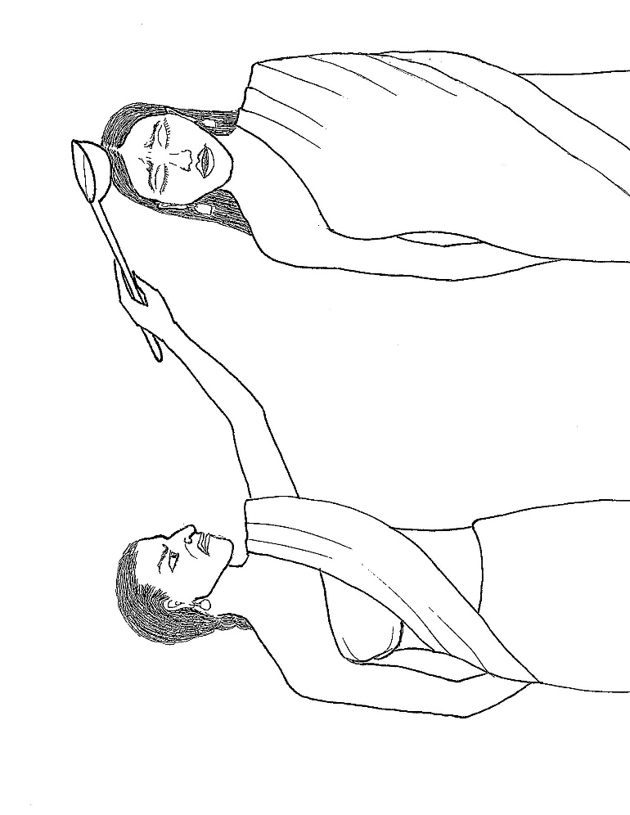

CHAPTER 11 – HOT OIL ATTACK

A young lady named Uttara and her parents were very devoted Buddhists. Uttara’s father arranged for her to be married to the son of a rich man. But after she was married, she was unhappy in her husband’s home because her husband wouldn’t allow her to offer food to the Buddha or listen to him teach the Dharma. Her husband said that if she did this, then she wouldn’t be at home to cook for him and clean the house and the laundry.

She told her father, “Why have you put me in this cage? Here I cannot see any monks and I have no opportunity to do any acts of merit!”

Her father felt sorry for her so he sent her a large amount of money. She asked her husband to allow her to spend her money to hire a lady to do the cooking and cleaning for him for a few days. He gave his permission, and then Uttara hired a lady named Sirima to do these chores for fifteen days.

During this time, Uttara carefully prepared large amounts of food at home and brought it to the Buddha and his monks for each day’s meal. On the fifteenth day, her husband was observing her as she was busily preparing food in the kitchen to bring to the monastery.

Then he smiled and muttered to himself, “How foolish she is! She doesn’t know how to enjoy herself. She is tiring herself out with this food offering ceremony!”

Sirima saw him smile. She thought that he was smiling at her. She felt flattered that this rich handsome man was smiling at her. So, she didn’t want him to be Uttara’s husband anymore; she wanted him all to herself. She forgot that she was hired by and was being paid by Uttara.

Suddenly she wanted to get rid of Uttara. She was very jealous of Uttara’s beauty and jealous that Uttara was married to this handsome wealthy man.

There was a pot of oil heating on the stove. Unable to control herself, she went over to the stove and took a ladle full of burning hot oil, intending to pour it over Uttara’s head.

Uttara saw Sirima coming. Uttara had no hatred or anger toward Sirima, and felt no hostility—no ill will—toward her.

Uttara thought, “Because Sirima took care of all the housework, I was able to listen to the Dharma, serve the Buddha and the monks, and perform other acts of merit. I feel so thankful, so grateful to Sirima.”

Suddenly, Sirima came very close and by the cruel expression on Sirima’s face, Uttara realized what Sirima was about to do—she was about to pour the boiling hot oil over her!

Still, Uttara had no ill will—she didn’t want to harm Sirima. Uttara made a firm resolution: “If I have any ill will toward Sirima, may this boiling oil burn me. If I have no ill will toward her, may it not burn me.”

Sirima quickly lifted the ladle and poured the oil on Uttara’s head. But, because Uttara had no hostile feeling toward Sirima, the hot oil was as harmless as if it was just cold water!

Sirima, expecting Uttara to scream in pain and anger, heard nothing from Uttara. She thought, “The oil must have become cold!” So, she ran to get another ladle full of burning hot oil.

Uttara’s assistants caught Sirima and beat her for doing such a horrible thing.

Uttara, with oil dripping from her hair and clothing, stopped her assistants from beating Sirima and told them, “Instead of beating her, rub her with healing ointment.”

Sirima then remembered that she was being paid by Uttara to work for her. She felt terribly ashamed of what she had done—trying to harm the woman who had given her a job.

She cried out to Uttara, “Oh madam, please forgive me!”

Uttara replied, “I have my father, I shall ask him whether I should accept your apology.”

Sirima said, “I will go to your father and apologize to him for what I have done to you.”

Uttara explained, “When I said ‘my father,’ I wasn’t referring to the father that brought me into this rebirth. I was referring to my father the Buddha, who has helped me break the cycle of rebirths, who has taught me the Dharma, the Noble Truths.”

Sirima responded, “Please take me to see the Buddha!”

Uttara agreed, and arranged for Sirima to offer the meal to the Buddha and his monks on the following day at Uttara’s house.

After the meal, the Buddha was told what had happened between Sirima and Uttara. Sirima admitted that she had done wrong to Uttara and begged the Buddha to advise Uttara to forgive her.

The Buddha asked Uttara, “How did you feel when Sirima poured boiling oil on your head?”

Uttara answered, “Lord, because I am grateful to Sirima, I resolved not to lose my temper or have any ill will toward her. I only radiate my lovingkindness toward her.”

The Buddha applauded her, saying, “Well done, well done, Uttara! By not having any ill will you have been able to conquer one who abuses you through hate.”

He added, “By being generous, you should conquer one who is stingy; by speaking truth you should conquer one who tells lies.”

The Buddha advised Uttara to forgive Sirima, and Uttara did so.

Questions:

1. Why was Uttara unhappy with her husband? (he wouldn’t allow her to make offerings to the Buddha, see any monks, or hear the Dharma)

2. Why did Sirima feel jealous of Uttara? (she was jealous of Uttara’s beauty and jealous that Uttara was married to the rich handsome man)

3. Why did Uttara feel grateful toward Sirima? (because Sirima took care of all the housework so Uttara could hear the Dharma and offer food to the Buddha and the monks and perform other acts of merit)

4. What did Uttara say to herself when she realized Sirima was going to pour hot oil on her? (if I have any ill will toward Sirima, then may the oil burn me, but if I have no ill will toward Sirima, may it not burn me)

5. Was Uttara burned by the oil? (no)

6. What did Uttara do when her assistants beat Sirima? (she told them to stop beating her but rub her with healing ointment instead)

What the Buddha said:

“Akkodhena jine kodhaṁ, asādhuṁ sādhunā jine,
jine kadariyaṁ dānena, saccena alikavādinaṁ.”
“Conquer anger by non-anger, conquer evil by good,
conquer the miser with generosity, and conquer the liar with truth.”

Dhammapada 223 (17:3)

Dharma discussion – Ill Will and Lovingkindness:

Sirima attacked her employer, Uttara, in a fit of jealousy.
She suddenly wanted to harm her. This emotion is called ill will.
Ill will is a feeling of hostility, wanting to hurt someone, or hoping that they get hurt or get their feelings hurt.
Ill will often arises along with anger, hatred, jealousy, or vengeance (wanting revenge).
Someone might have ill will toward us if they are jealous of the attention we get from others, or our skill, our talent, our popularity, or how we look.

Imagine how you would react if someone attacked you, hit you or harmed you in some way.
Naturally, we might feel angry, shout at them, stay away from them, and report their behavior to a responsible adult.
We do that to protect ourselves, as a warning, and to show we won’t let them abuse us again.
But afterward, when they’re no longer with you, how would you feel toward them?
Some of us might feel ill will, and want to hurt them in return or hope they get hurt so they “learn a lesson” and never do it again.
But does ill will help us feel better? No.
It makes us more stressed; we feel tense when we see or even think about the person.
It fills our mind with bad thoughts about the person; these thoughts are not pleasant.
So, we are harming ourselves with this stress long after the person hurt us.

How can we avoid the stressful feeling of ill will?

First, we can calm ourselves by remembering that their bad actions—their negative karma—will punish them automatically; there is no need for us to punish them.
Remember that if we punish them, then we increase our own anger and ill will, and we risk creating negative karma for ourselves. And, they may retaliate and hurt us in return.
So, since there is no need to punish them, we can relax and think about better things.

Next, we can calm our feelings of anger and ill will by remembering that they tried to hurt us because of their own pain, their own suffering.
No one attacks or threatens another when they are happy; it’s because they feel so unhappy that they want to harm others.
We can try to feel compassion for their suffering.
If they were happy, peaceful and free from suffering, then they wouldn’t want to harm others.
So, we can wish that they be happy, peaceful and free from suffering.

If the person is a friend, brother, sister, someone you don’t know, or someone who isn’t usually misbehaved, or if they apologize, you could assume—or tell them—that they must have been having a bad day that made them so upset with you.
So you can forgive them, at least in your own mind, and wish that things get better for them. Then, it’s easier to be friendly with them again.

Another way to avoid the stressful feeling of ill will is to think of something good about the person—something that they did that was kind or helpful to you.
Then, like Uttara, you can feel grateful for that kindness or help they gave you.

Or, consider that their bad behavior helped you learn to control your anger and ill will, and to practice patience.
In that way, they have helped you become a better person. And you can feel grateful for that.

Finally, we can calm our anger and ill will by practicing lovingkindness.
Like Uttara, we can radiate our lovingkindness to that person as well as to all beings in all directions, like a candle flame radiates light in a dark room, or like the sun radiates light in all directions in dark space.
It’s easier to calm our feelings of anger and ill will when we practice lovingkindness meditation and when we practice lovingkindness toward others in our daily life.

An example of lovingkindness meditation is to say aloud and contemplate:
May I be well, happy and peaceful.
May my family and friends be well, happy and peaceful.
May all beings who are angry, hateful, harmful, or jealous be well, happy and peaceful.
May all beings be well, happy and peaceful.

Chapter 12 picture

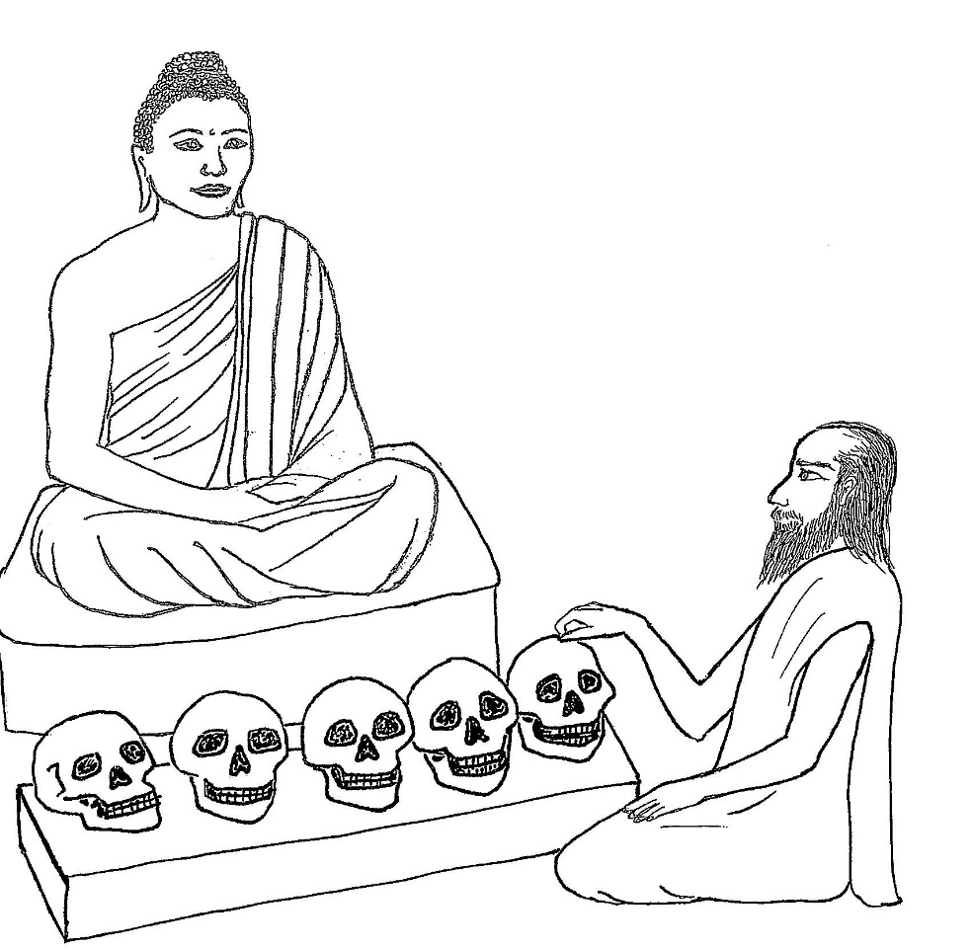

CHAPTER 12 – THE SKULLS

There was once a man named Vangisa who had a very unusual talent. He could tell in which world a dead person was reborn. He could tell this by tapping on the skull of the dead body.

He would tap on one skull and say, “This is the skull of a man who has been reborn in a hell-world.”

He would tap on another skull and say, “This man has been reborn as an animal.”

He would tap on a different skull and say, “This man has been reborn as a ghost.”

And he would tap on another skull and say, “This is the skull of a man who has been reborn in the human world.”

He would tap on yet another skull and say “This person has been reborn in a heaven-world.”

Many people asked him to come and tap on the skull of a family member, a friend, or an enemy who died, to tell the future existence of the person. People were very curious to know if the good or bad behavior of the person in their lifetime resulted in a lucky or unlucky rebirth—whether it led to a rewarding next life in heaven or a punishing next life in a hell-world or as a ghost or animal. And they wanted assurance that their loved ones had a good rebirth. So, many people were willing to pay Vangisa money for his special talent.

There was a group of brahmin men who lived in his town who thought to themselves, “We can use this man to take advantage of people all over the world!” They made a plan to take him all around India and persuade people everywhere to give them money for Vangisa to tell what happened to their relatives after death. The brahmins thought this would make them rich and famous!

They gave him red robes to wear, to look like an important, respected holy man. They brought him to towns and villages all over the country, traveling as a group, saying to everyone they met,

“This holy man Vangisa can tell by tapping on the skulls of dead men in which world they have been reborn. Ask him to tell you in which world your own family members have been reborn.”

People would give him ten pieces of money, or twenty, or a hundred, according to the amount of wealth they had, showed him a dead body and asked him about the rebirth of the person.

One day, Vangisa and his group reached the city of Savatti and camped near the Buddha’s famous monastery called Jetavana. After breakfast, they were surprised to see crowds of people going toward the monastery carrying perfumes, flower garlands, and fruits in their hands.

Men from Vangisa’s group asked some of these people, “Where are you going?”

The townspeople replied, “To the monastery to hear the Dharma.”

The brahmin men asked, “What will you gain by going there?”

Without waiting to hear an answer, they said, “There is nobody like our holy man, Vangisa. He can tell by tapping on the skulls of dead men in which world they have been reborn. Just ask him in which world your own relatives have been reborn.”

The people of Savatti replied, “What does Vangisa know? There is no one like our teacher.”

The friends retorted, “There is no one like Vangisa!”

Soon, the men of Vangisa’s group and the townspeople were arguing with each other.

Finally, the townspeople—the devotees of the Buddha—said, “Come now, let’s go find out which of the two knows more, your Vangisa or our teacher.”

They led Vangisa and his group to the monastery.

The Buddha knew that they were on their way, and before they arrived, he requested an assistant to bring him certain human skulls. The assistant brought the five skulls and the Buddha arranged them in a row near his seat. The Buddha knew that the person to whom one of the skulls had belonged had been reborn in a hell world, the second skull’s owner was reborn in the animal world, the third one’s owner was reborn as a human, and the fourth one’s owner had been reborn in a heaven world. The owner of the fifth skull had become an arahant.

When Vangisa and his friends arrived, the Buddha asked Vangisa, “Are you the man of whom it is said that by tapping on the skulls of dead men you can tell in which world they have been reborn?”

“Yes,” said Vangisa.

The Buddha pointed to the first skull and asked, “Then whose is this skull?”

Vangisa tapped on the skull and said, “This is the skull of a man who has been reborn in hell.”

The Buddha exclaimed, “Good, good!” and applauded him.

Then the Buddha asked about the next three skulls, and Vangisa answered without making a mistake. The Buddha applauded him for each answer he gave. Finally, the Buddha pointed to the fifth skull.

“Whose skull is this?” the Buddha asked.

Vangisa tapped on the fifth skull as he had done on the others. He was silent.

Then he said, “I don’t know into which world this man has been reborn.”

The Buddha said, “Vangisa, you don’t know?”

“No,” replied Vangisa, “I don’t know.”

The Buddha said, “I know.”

Then Vangisa asked him, “Teach me this charm.”

The Buddha replied, “I cannot teach it to one who has not been ordained as a monk.”

Vangisa thought to himself, “If I only knew this charm, I would be the most famous man in all of India.” He didn’t want to be embarrassed by not knowing where a dead person was born, or by guessing wrong—saying that an evil person went to a heaven-world or that a good person went to a hell world. Then people would lose respect for him. He thought he could just learn some kind of magic charm or technique from the Buddha for finding out where the person who owned the fifth skull was reborn.

Vangisa turned to his group and told them that he wanted to learn the technique for finding out where the person who owned the fifth skull was reborn. He said he would learn it as soon as possible from the Buddha.

He told them, “Remain here for a few days. I intend to be ordained as a monk.”

The group stayed at their camp near the monastery, and Vangisa became ordained by the Buddha as a monk and joined the other monks. He was then called Venerable Vangisa.

The monks instructed Venerable Vangisa to meditate on the 32 parts of the body, and to repeat the first words of the instructions. He followed their instructions very carefully and practiced meditation very diligently.

Over the next few days, whenever Venerable Vangisa saw the brahmins from his group, they asked him, “Have you learned the technique?”

Each time, he answered, “Just wait a little! I am learning it.”

After a few days, Venerable Vangisa became enlightened as an arahant.

The group of brahmins asked him again, “Have you learned the technique yet?”

This time, he replied, “Friends, I am now unable to learn it.”

Some monks heard this conversation and went to the Buddha, saying, “Lord, this monk says what is not true; he is guilty of dishonesty.”

The Buddha replied, “Monks, do not say so. Monks, my son now knows all about the passing away and rebirth of all beings.”

He continued by saying these stanzas:
“He who knows the death and birth of beings in every way, who is detached, disciplined and enlightened, that one I call a true brahmin.”

“Those whose future is unknown to humans, spirits or gods, pollutions destroyed, an arahant, that one I call a true brahmin.”

Questions:

1. What did the group of brahmin men want to do with Vangisa? (use him to persuade people all over India to give them money)

2. What did they hope would happen to them by taking Vangisa all around the country? (they would become rich and famous)

3. How did Vangisa and his groups end up visiting the Buddha? (the people of Savatti took them to the Buddha after they got into an argument with Vangisa’s group over whose teacher knew more, the Buddha or Vangisa)

4. What did Vangisa say when he tapped on the fifth skull? (he said that he didn’t know where the man was reborn)

5. Why did Vangisa become a monk? (so he could learn the technique to find out where the owner of the fifth skull was reborn; the Buddha said he had to become a monk to learn it)

6. Did Vangisa finally learn what happened to the owner of the fifth skull? (yes)

What the Buddha said:

“Cutiṁ yō vēdi sattānaṁ, upapattiṁ ca sabbasō, asattaṁ sugataṁ Buddhaṁ, tamahaṁ brūmi brāhmaņaṁ.”
“Yassa gatiṁ na jānanti, deva gandhabbamānusā, khīņāsavaṁ arahantaṁ, tamahaṁ brūmi brāhmaņaṁ.”
“He who knows the death and birth of beings in every way, who is detached, disciplined and enlightened, that one I call a true brahmin.”
“Those whose future is unknown to humans, spirits or gods, pollutions destroyed, an arahant, that one I call a true brahmin.”

Dhammapada 419, 420 (26:37, 26:38)

Dharma discussion – Power:

The group of men wanted to use Vangisa as a way to make money and become famous.
They wanted to use his power so they could become powerful, too—with money and fame.
When they went to Savatti,, they wanted to persuade the people that Vangisa was more interesting and knowledgeable than the Buddha.
They weren’t interested in the Dharma or learning anything from the Buddha; they just wanted to make money.

When he first met the Buddha, was Vangisa interested in the Dharma?
No, he was only interested in showing his power, and when it wasn’t enough to determine the rebirth of the fifth skull, he wanted to enhance his power by learning a technique to make sure he could continue predicting the rebirth of every dead person.
So, he was willing to become a monk to increase his power, and he probably planned to leave the Buddha and go back to his group and travel with them again once he learned the technique.

Vangisa and his group were fascinated with his mystical or psychic power.
They thought that those kinds of powers were the most impressive and important.

They were so greedy for money, fame and power that they weren’t interested in the Dharma, even when the Buddha was sitting directly in front of them!

But, what happened to Vangisa when he actually tried practicing the Dharma?
He became enlightened as an arahant.
Then, what happened to his plan to learn the technique for finding out the rebirth of owner of the fifth skull?
He probably dropped that plan because he found out what an arahant was—someone who is not reborn anymore, who has no more rebirths as a human, in a god-world, as an animal, or any lower world.
He told his friends he was unable to learn the technique that he had planned to learn.
Why would he say that?
Because no one can learn where an arahant is reborn when there is no rebirth for an arahant.

In today’s world, many people are like the men in Vangisa’s group.
They are so focused on making money and becoming more popular that they ignore the Dharma; they aren’t interested in spirituality.
And many people who are interested in spirituality are fascinated by supernatural or psychic powers.
Like Vangisa at first, they just want to learn those powers—how to train their mind so they can get mystical or psychic powers and impress people, be admired and popular.
But then they are just feeding their ego, becoming more egoistic.
Most people think that money, popularity and power will make them happy.

But, the ego is never fully satisfied—it’s always looking for more attention, more power; it never has enough.
How can we really feel satisfied—how can we feel more content?
We can feel more content when we learn and practice the Dharma.
That is when we start to unlock the true power of our mind.

What is the true power of our mind?
It’s what the Buddha was seeking and what he found when he became enlightened—the way to the end of suffering, and unending peace and ultimate wisdom.

That seems like a long, long way off into the future for us.
But we can enjoy at least some of the peace and wisdom even now.
Meditation and mindfulness give our mind a break, let it relax from the stress of daily life.
And they give us a more positive perspective—a better way of looking at things.
Lovingkindness and compassion turn our minds away from stressful thoughts to positive ones.
And making merit by doing good deeds creates a better future for us.
When we can reduce our stress and dissatisfaction by these practices, then some of the biggest problems that people are facing, all around the world—too much stress and worry—we are conquering right now, when we are young.

